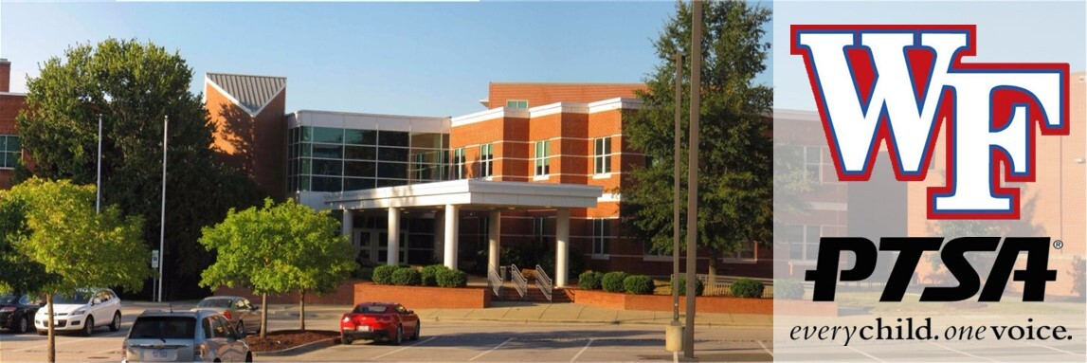

Wake Forest High School PTSA Newsletter

Welcome to our June newsletter!

Please scroll to the bottom of this email, and be sure to click “view entire message”. Gmail is cutting off the bottom part of the newsletter! Be sure you add ptsa.wfhs@gmail.com to your contacts so our messages won’t go to spam or get lost in your promotions.
We can’t believe the school year is almost over! Thank you to all our members, volunteers, and board for a great year!

Our final Board meeting for this year will be on Monday, June 1st at 5:45pm in the media center. This will be a quick meeting to wrap up the school year, followed by a meet and greet at Strike and Barrel at 6:30pm! We invite you all to come to both, or just come to strike and barrel to have a good time and celebrate the end of the year with us!

Please consider helping out and joining our PTSA board! Our organization is solely volunteer run, and without more of you, we cannot continue to support things for our students and staff! Some roles we need filled for next year are Membership, Advocacy, Fundraising/Spirit Nights, Senior events and Hospitality co-lead. Please reach out if you are interested. If there is something else you would like to do, we can find a role best suited to your talents. Come to our board meeting or reach out to learn more.

Important School Info
Exam Schedule: Students should only come to school on days they have an exam. They may leave after their scheduled exam if they have filled out an early release form, or come in late if they have a late exam only. Please see the schedule below.
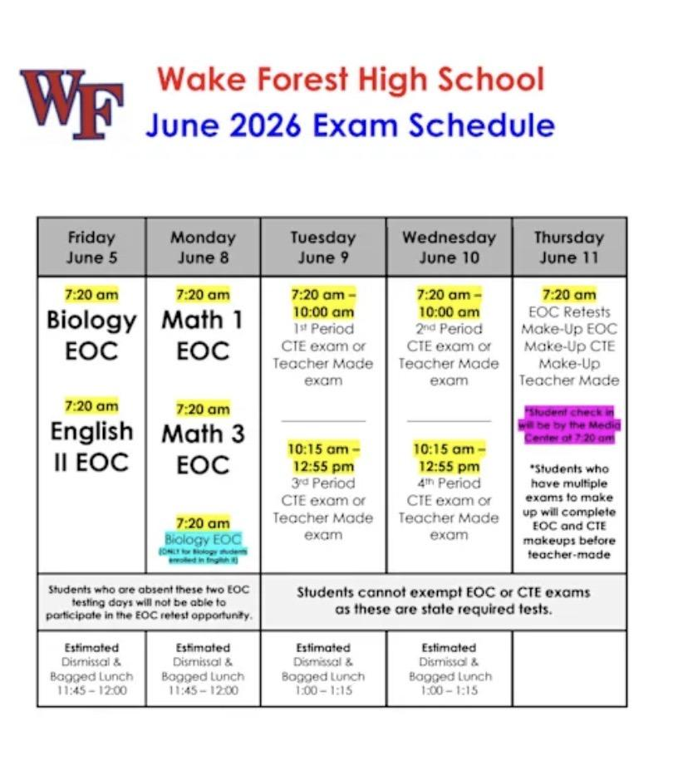
Save the date! Cougar camp for incoming freshmen will be August 6th. More info to come.
Staff and Club Grants

We have been busy over the last few months purchasing valuable supplies for our classrooms to enhance and support instruction.
For our OCS team we purchased Wobble chairs, light diffusers, and sensory products, among other things, to support those classes.
Our Multi Language classes are getting games and other tools to help with learning English as a second language.
For our Foods Classes we are purchasing skillets, utensils, and recipe boards so they can apply classroom lessons with cooking.
For our PE classes we are purchasing athletic supplies.
For our Collision Repair club we have purchased grinders and for our Dungeons and Dragons club we are purchasing filament for the 3D printer so they can custom make playing pieces.

Advocacy

One of our main focus points with Advocacy is Health and Wellness. We have been trying to spread awareness with our student health and wellness committee, as well as provide useful information that may help parents have meaningful conversations with their kids. Here is our focus for June:

Ending the School Year Strong: A Summer of Self-Care for Parents and Teens
As another school year comes to a close, many families are looking forward to a slower pace, sunny days, vacations, and a much-needed break from busy schedules. While summer often brings excitement and relaxation, it is also the perfect time to focus on something that is frequently overlooked during the school year: self-care.

Self-Care for Teens
Today's teens face tremendous pressure from academics, extracurricular activities, social media, jobs, and preparing for their futures. Summer provides a valuable opportunity to recharge both mentally and physically.
Encourage your teen to:
- Maintain a healthy sleep schedule.
- Stay active through sports, walking, swimming, or other enjoyable activities.
- Limit excessive screen time and spend time outdoors.
- Nurture friendships and positive social connections.
- Explore hobbies, volunteer opportunities, or new interests.
- Practice mindfulness, journaling, or other stress-management techniques.
While summer should include fun and relaxation, maintaining some structure can help teens feel balanced and prepared for the upcoming school year.

Self-Care for Parents
Parents often spend the school year focused on meeting everyone else's needs. Summer is a great reminder that caring for yourself is not selfish—it is essential.
Consider:
- Making time for exercise and healthy eating.
- Scheduling moments of rest and relaxation.
- Connecting with friends and supportive family members.
- Setting boundaries around work and family obligations.
- Pursuing hobbies and activities that bring joy.
- Practicing gratitude and mindfulness.
Even small acts of self-care can improve energy levels, reduce stress, and help parents show up as their best selves for their families.

For Families Sending a Child to College
For many parents, this summer marks a major life transition as they prepare to send a child off to college. Along with excitement and pride often comes anxiety, sadness, uncertainty, and stress. These feelings are completely normal.
Parents may find themselves wondering:
- Have I prepared them enough?
- What will life at home be like?
- How will I handle the changes ahead?
The transition to college affects the entire family. It is important for both students and parents to acknowledge the emotions that come with this new chapter.
Helpful tips include:
- Talk openly about expectations and feelings.
- Focus on quality family time before move-in day.
- Celebrate your student's accomplishments.
- Give yourself permission to experience mixed emotions.
- Stay connected while allowing your student space to grow and become independent.
Remember, sending a child to college is not an ending, it is the beginning of a new and exciting season for both students and parents.

A Final Thought
As summer begins, challenge yourself and your family to prioritize well-being. Whether it is taking a walk, spending time together, trying something new, or simply slowing down, self-care can help everyone return in the fall refreshed, resilient, and ready for new opportunities.
Wishing all of our families a safe, healthy, and relaxing summer!

Spirit Nights

Thank you to everyone who came out to our Zaxby’s spirit night. We earned $400! You have all been amazing supporting our local businesses and our school this year!
Hospitality
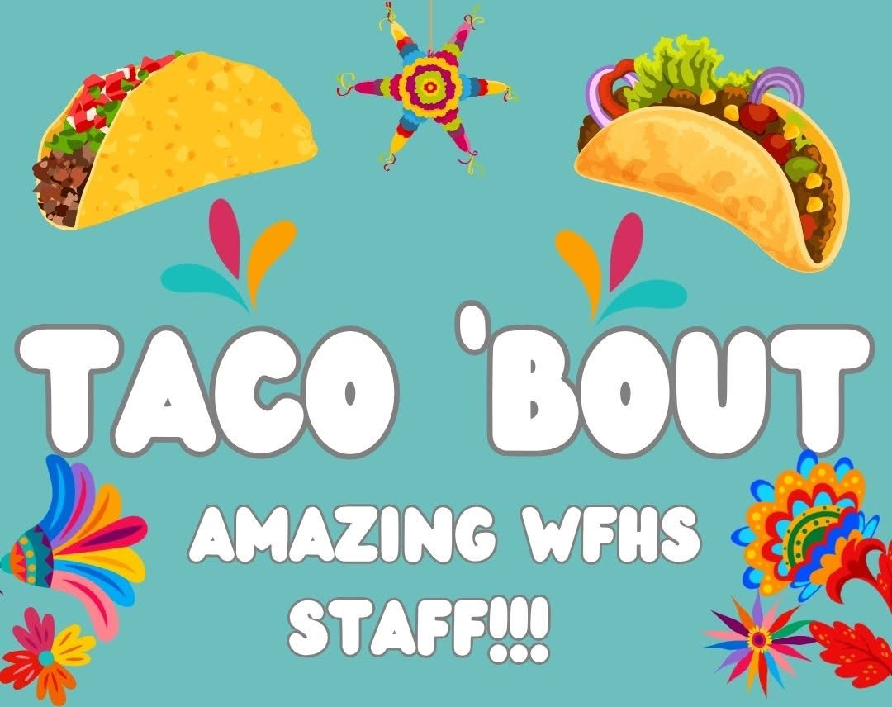
Thanks to our parents who volunteered and donated supplies to staff appreciation week this year! Our staff received a wonderful lunch with tacos, chips and queso/salsa, fruit, salads and an array of different desserts! A special shout out to Cravin’ Confections for providing gluten free desserts for the staff as well!
We also provided a continental breakfast with pastries, fruit, bagels donated by Jeff’s Bagel Run, oatmeal and of course coffee and tea! We love our staff!

Want to find out how to help with fun events like this? Join the PTSA and email us at ptsa.wfhs@gmail.com to get in on the fun!

Graduating Class of 2026

Class of 2026 Senior Picnic
Thank you to everyone who donated and volunteered at the picnic on May 28th! It was a lot of planning and hard work, and it went perfectly! The students had a blast playing cornhole, pickleball, doing relay races, dancing and singing to karaoke and just relaxing! There was a photo booth and tons of food, including walking tacos, sandwiches, gluten free pizzas, ice cream, cotton candy, popcorn and more!
We wanted to give a special shout out to businesses that donated or helped with our picnic. So thank you to Culver’s for donating ice cream for everyone, Los Tres Magueyes Wake Forest for our Taco meat, Firehouse Subs for the sandwich lunchmeat, Marco’s Pizza Rogers rd for the gluten free pizzas, Food Lion, Publix, Walmart and Sam’s Club for gift card donations! Our Karaoke DJ Arrick Cox was on point and the students had a blast singing and dancing with each other and staff! We have a truly amazing community.
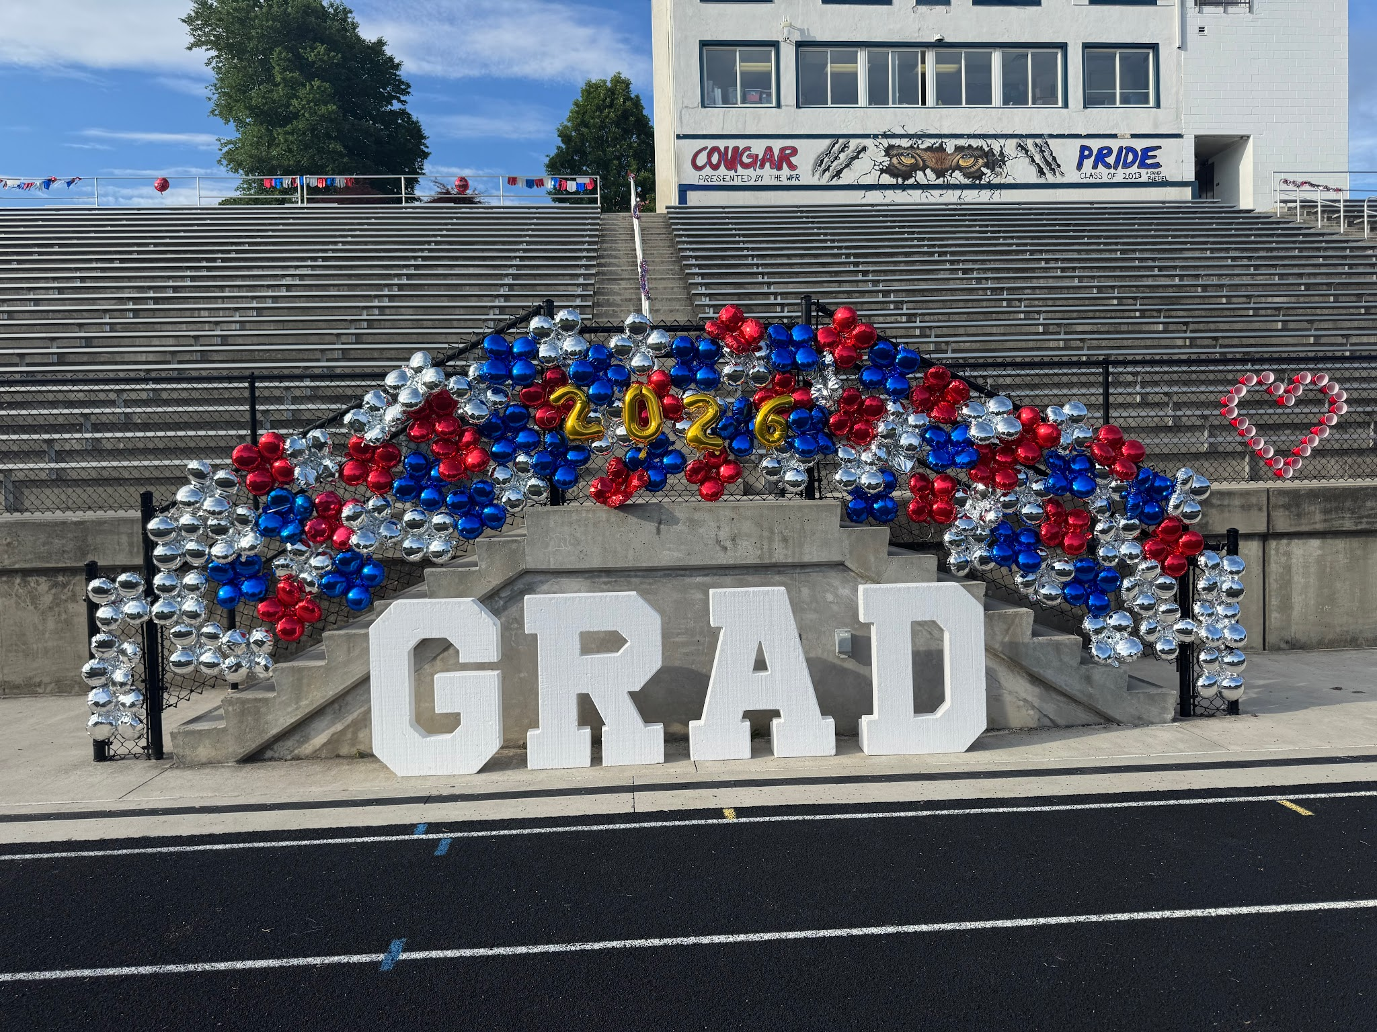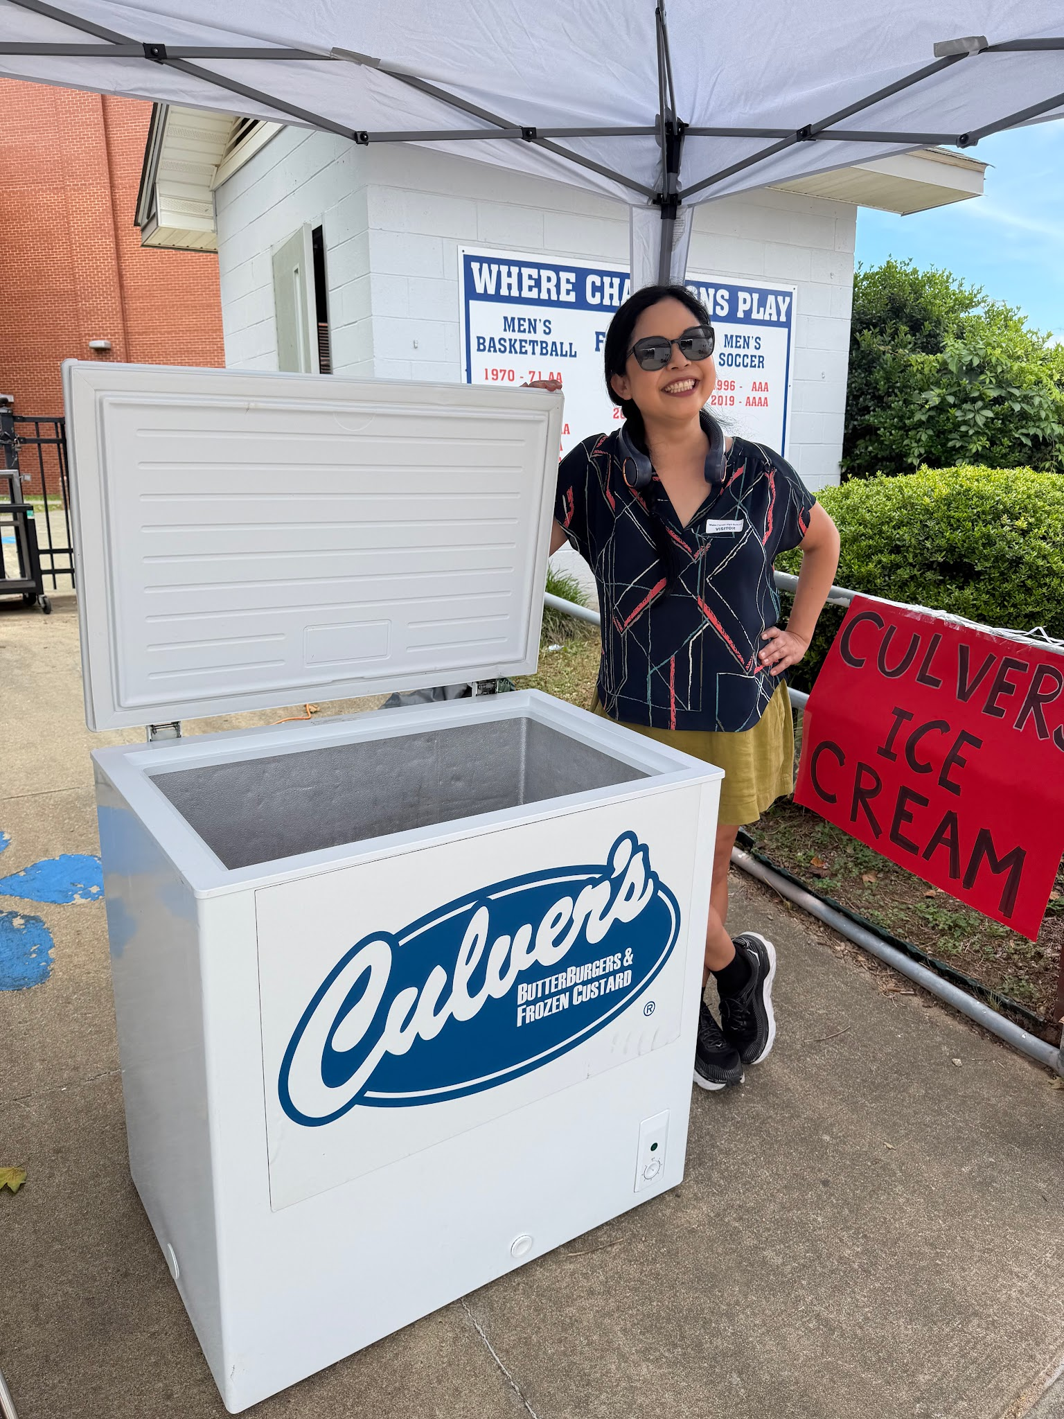
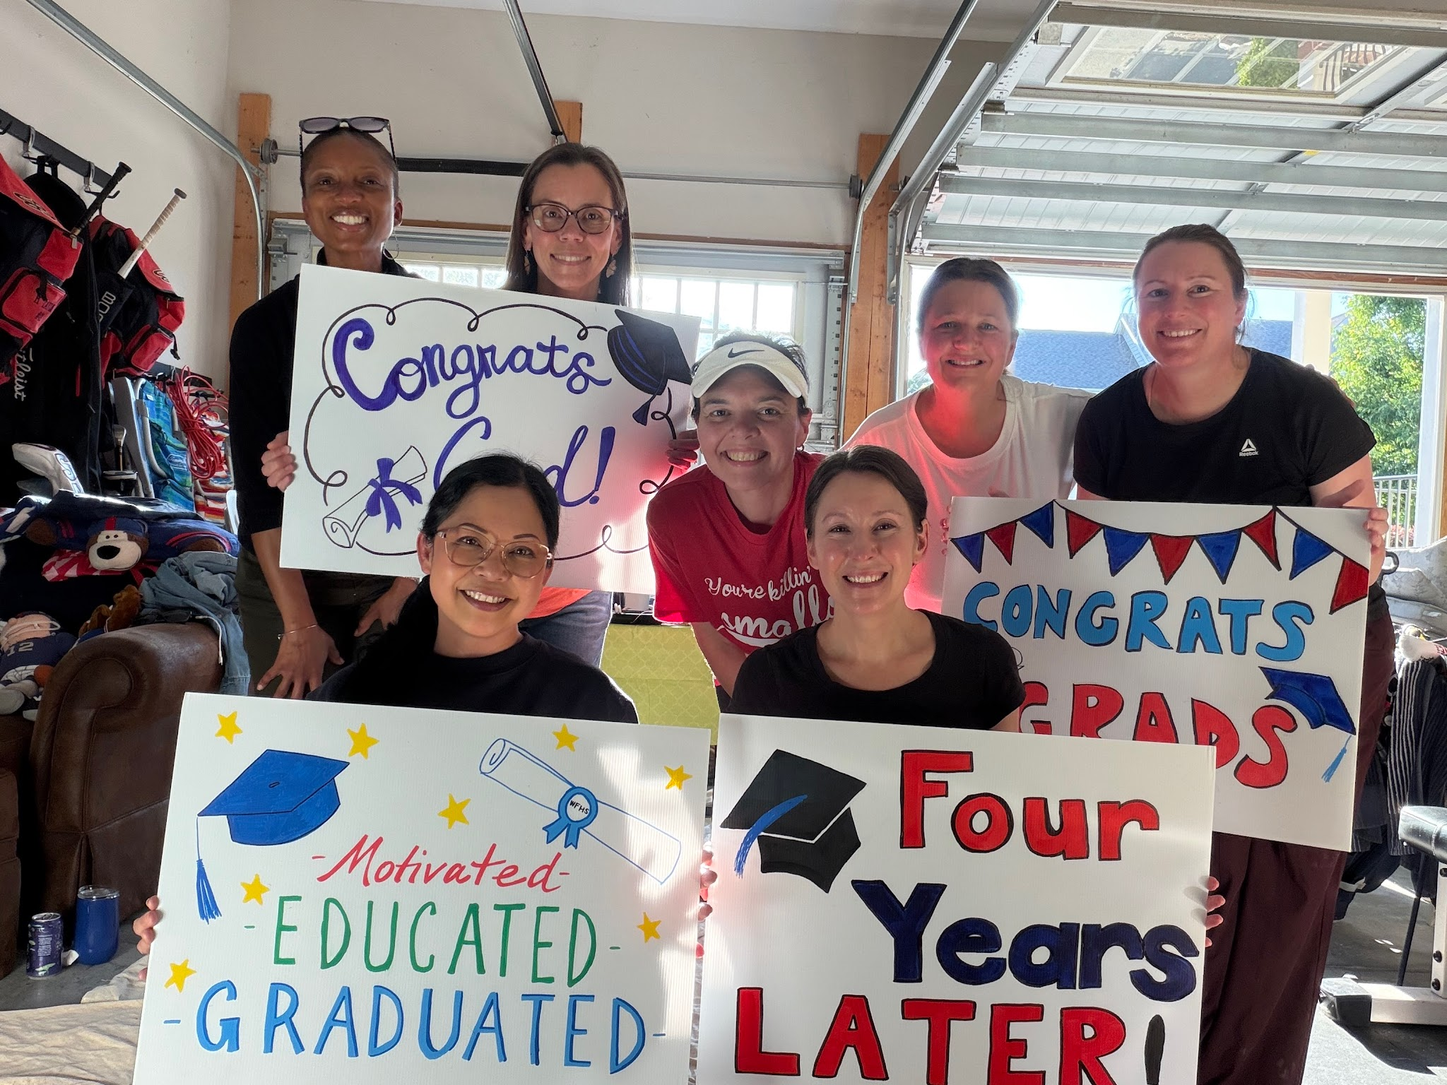
Other Important Info:

Senior Dues – Senior Dues may be paid using this link and must be paid in full in order to receive your 9 graduation tickets! Please do so ASAP.

Important Upcoming Dates:
Jun 11th: Mandatory Graduation practice 1-3pm in main gym
Jun 15th: Graduation at 4pm at the Raleigh Convention Center

Congrats to Mr. Hasenfus on being WFHS Teacher of the Year this year!
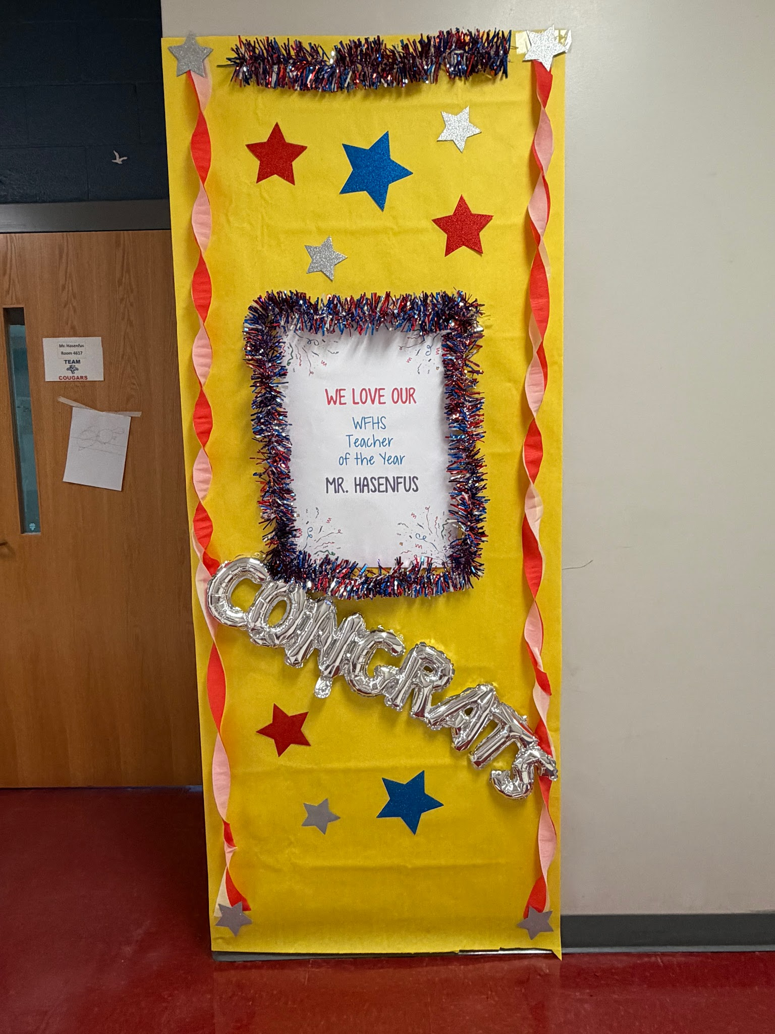
Attendance:
As we head into summer break, we want to thank our families for supporting student success throughout the school year. Regular school attendance is one of the strongest factors in academic achievement, helping students stay engaged, build relationships, and develop positive habits for the future.
Summer is a great time for students to rest, recharge, and prepare for the year ahead. We encourage families to support healthy routines, reading, staying active, and taking time to relax and reconnect.
Thank you for your continued partnership and commitment to your student’s education. We look forward to welcoming everyone back for another great school year!
Donate to the Giving Tree!

The Giving Tree is one of our biggest fundraisers every year, and it is a super easy way to help our school earn money! We were in first place again this year and earned $4550 to help support our school!! So thank you to everyone who donated and shopped at the giving tree last year! Here’s how it works:
The Giving Tree is a local non-profit that accepts donations from the community with the specific goal of using the proceeds to generate funds for local schools! Donating is simple. All you do is grab a paper bag or box, fill it with gently used home goods or toys, and drop it off at the giving tree (839 South Main St) any time Monday-Saturday from 10:30-4:30. There is a list of allowed goods and donation instructions on the DONATE page of their website. You get points for every donation and points every time you shop, so don’t forget to look around while you are there. They are the cutest boutique!
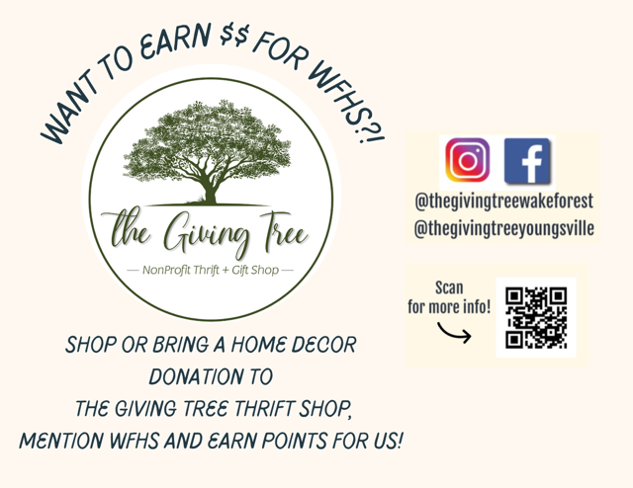

You can Link your Rewards Cards to give back to the school.
It takes just a couple minutes to do on your own and costs nothing. Go to the Fundraising page on our website to enter your information for Lowes Foods or click the links to go directly to the applicable page on each store’s website. From August 1-July31, a portion of everything you buy at these stores will go to support the school, and you don’t have to do a single thing after linking it except shop as you normally would.



Helpful WFHS Links
Need to find a WFHS-related page, but can't find it ANYWHERE? Yeah, we get it! Here's your one-stop list of (almost) all things WFHS! If we're missing something, let us know so we can add it! Also follow WFHS PTSA on facebook, instagram and twitter!
Grade-Specific Facebook Pages
Freshman Class of 2029 Facebook Page
Sophomore Class of 2028 Facebook Page
Junior Class of 2027 Facebook Page
Senior Class of 2026 Facebook Page

READ MORE ON OUR WEBSITE


WFHS PTSA

