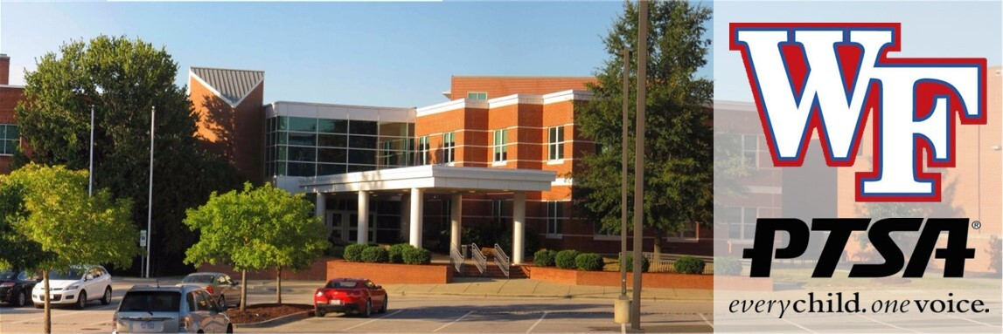

Wake Forest High School PTSA Newsletter

Welcome to our September Newsletter!

We’ve had a great start to the 2026-27 school year!
Save the date! Our first General Membership meeting will be held on Wed, Sept 9th immediately following the school’s “Meet the Teacher” event. It will last approximately 15 minutes and will start around 7:05 p.m. in the Media Center. We need a minimum of 20 current PTSA members in attendance to pass our 2026-27 budget. Please come out to approve our budget and learn about all the fun things planned for this school year!
Our next board meeting will be on Monday, Sept 14th at 6 p.m. in the Media Center. Please email us at ptsa.wfhs@gmail.com if you need the Google Meet link to join virtually. Otherwise, we would love to see you there in person as we discuss our plans for this year!

WFHS Cougar No-Fuss Fundraiser and PTSA Membership

Our No-Fuss-Fundraiser has begun!! Small Gifts. BIG Impact!
This is our biggest fundraiser of the year! Instead of selling cookie dough, wrapping paper, or magazines, we're asking every WFHS family to consider making a one-time, tax-deductible donation to support our school.

Why "No Fuss"?
 No selling!
No order forms!
No deliveries!
100% of your donation stays at Wake Forest High School!
Your generosity helps fund:
-  Student Scholarships
-  Teacher & Classroom Grants
-  Senior & Student Activities
-  Campus Improvements
-  Teacher & Staff Appreciation
-  Student Clubs & Programs
Whether you can give $10, $25, $50, or more, every gift makes a difference!!!
 Goal: $5,000
Ready to Make an Impact Today?
 Visit https://www.wfhs-ptsa.com/memberships-and-donations to donate and/or join the PTSA today!
Together, we can make this our most successful year yet!
Small Gifts. BIG Impact. Every Student Benefits.

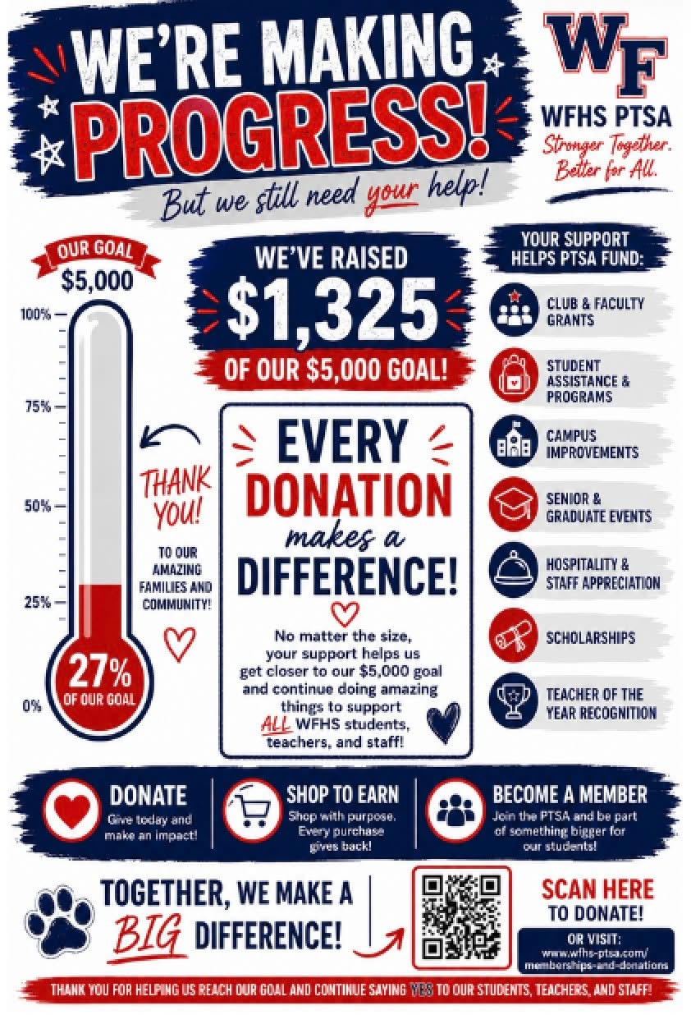

Spirit Night
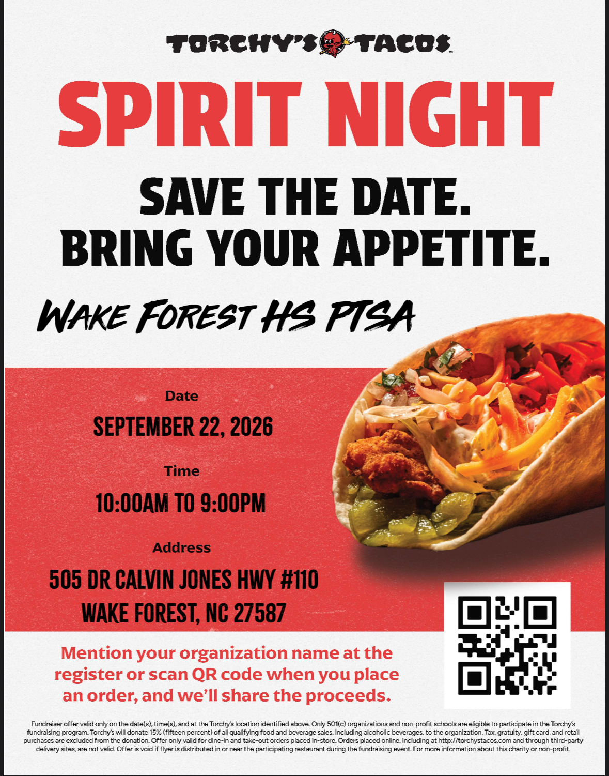

Ready to Volunteer?
You should have received an email about renewing your WCPSS volunteer status this year. Please make sure you do this asap so you can help out when you want to!

Hospitality

Cougar Dash
Our next hospitality event for this year will be on Wed, Sept 16th.
This is our version of Door Dash, where we fill a cart with tons of snacks and drinks and deliver them door-to–door to staff during the school day! If you would like to help us by donating snacks and/or volunteering to help, please click to sign up here. Short on time? You can also donate gift cards and email our PTSA the link.
Want to find out how to help with fun events like this? Join the PTSA and email us at ptsa.wfhs@gmail.com to get in on the fun!

Appreciation Post

Last month, we sponsored a staff lunch on Aug 18th to welcome back our teachers and staff. They enjoyed sandwiches, pasta salad, a salad with all the fixings, chips, and desserts! Thank you to everyone who donated and to our amazing volunteers who helped prepare and serve the food. It takes a village, and we really appreciate all you do to show our school how special we think they are!

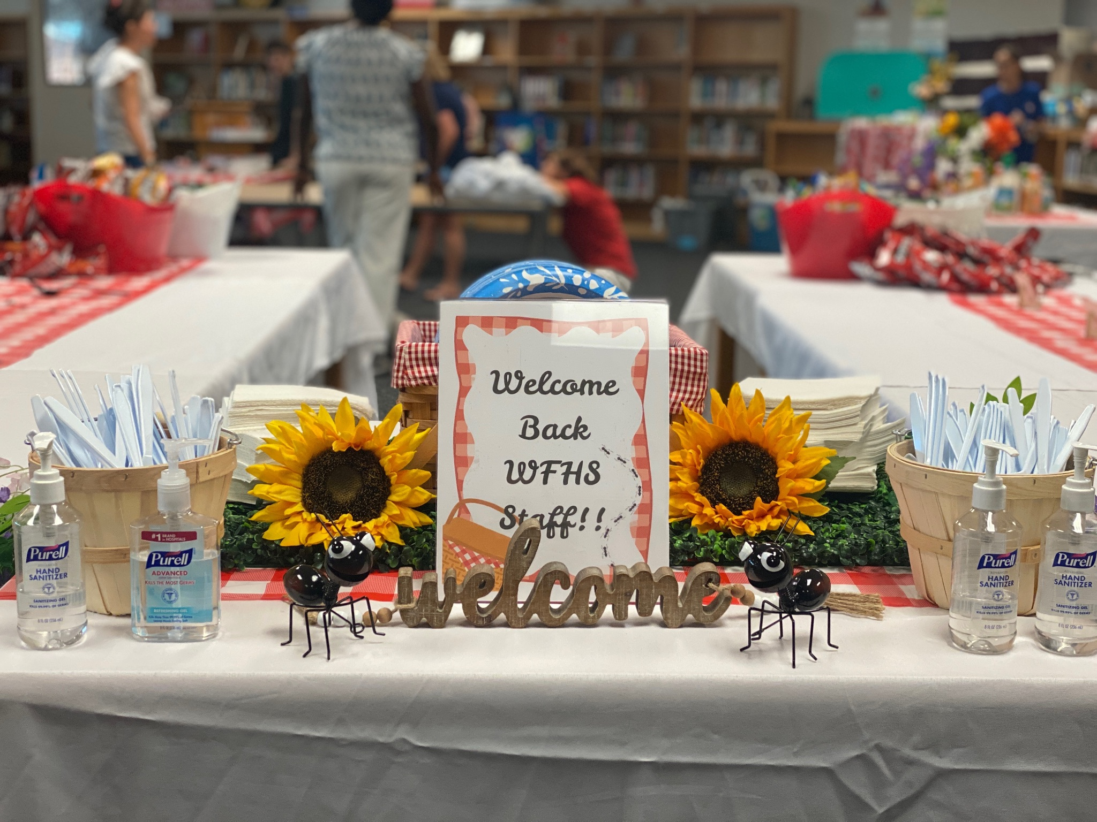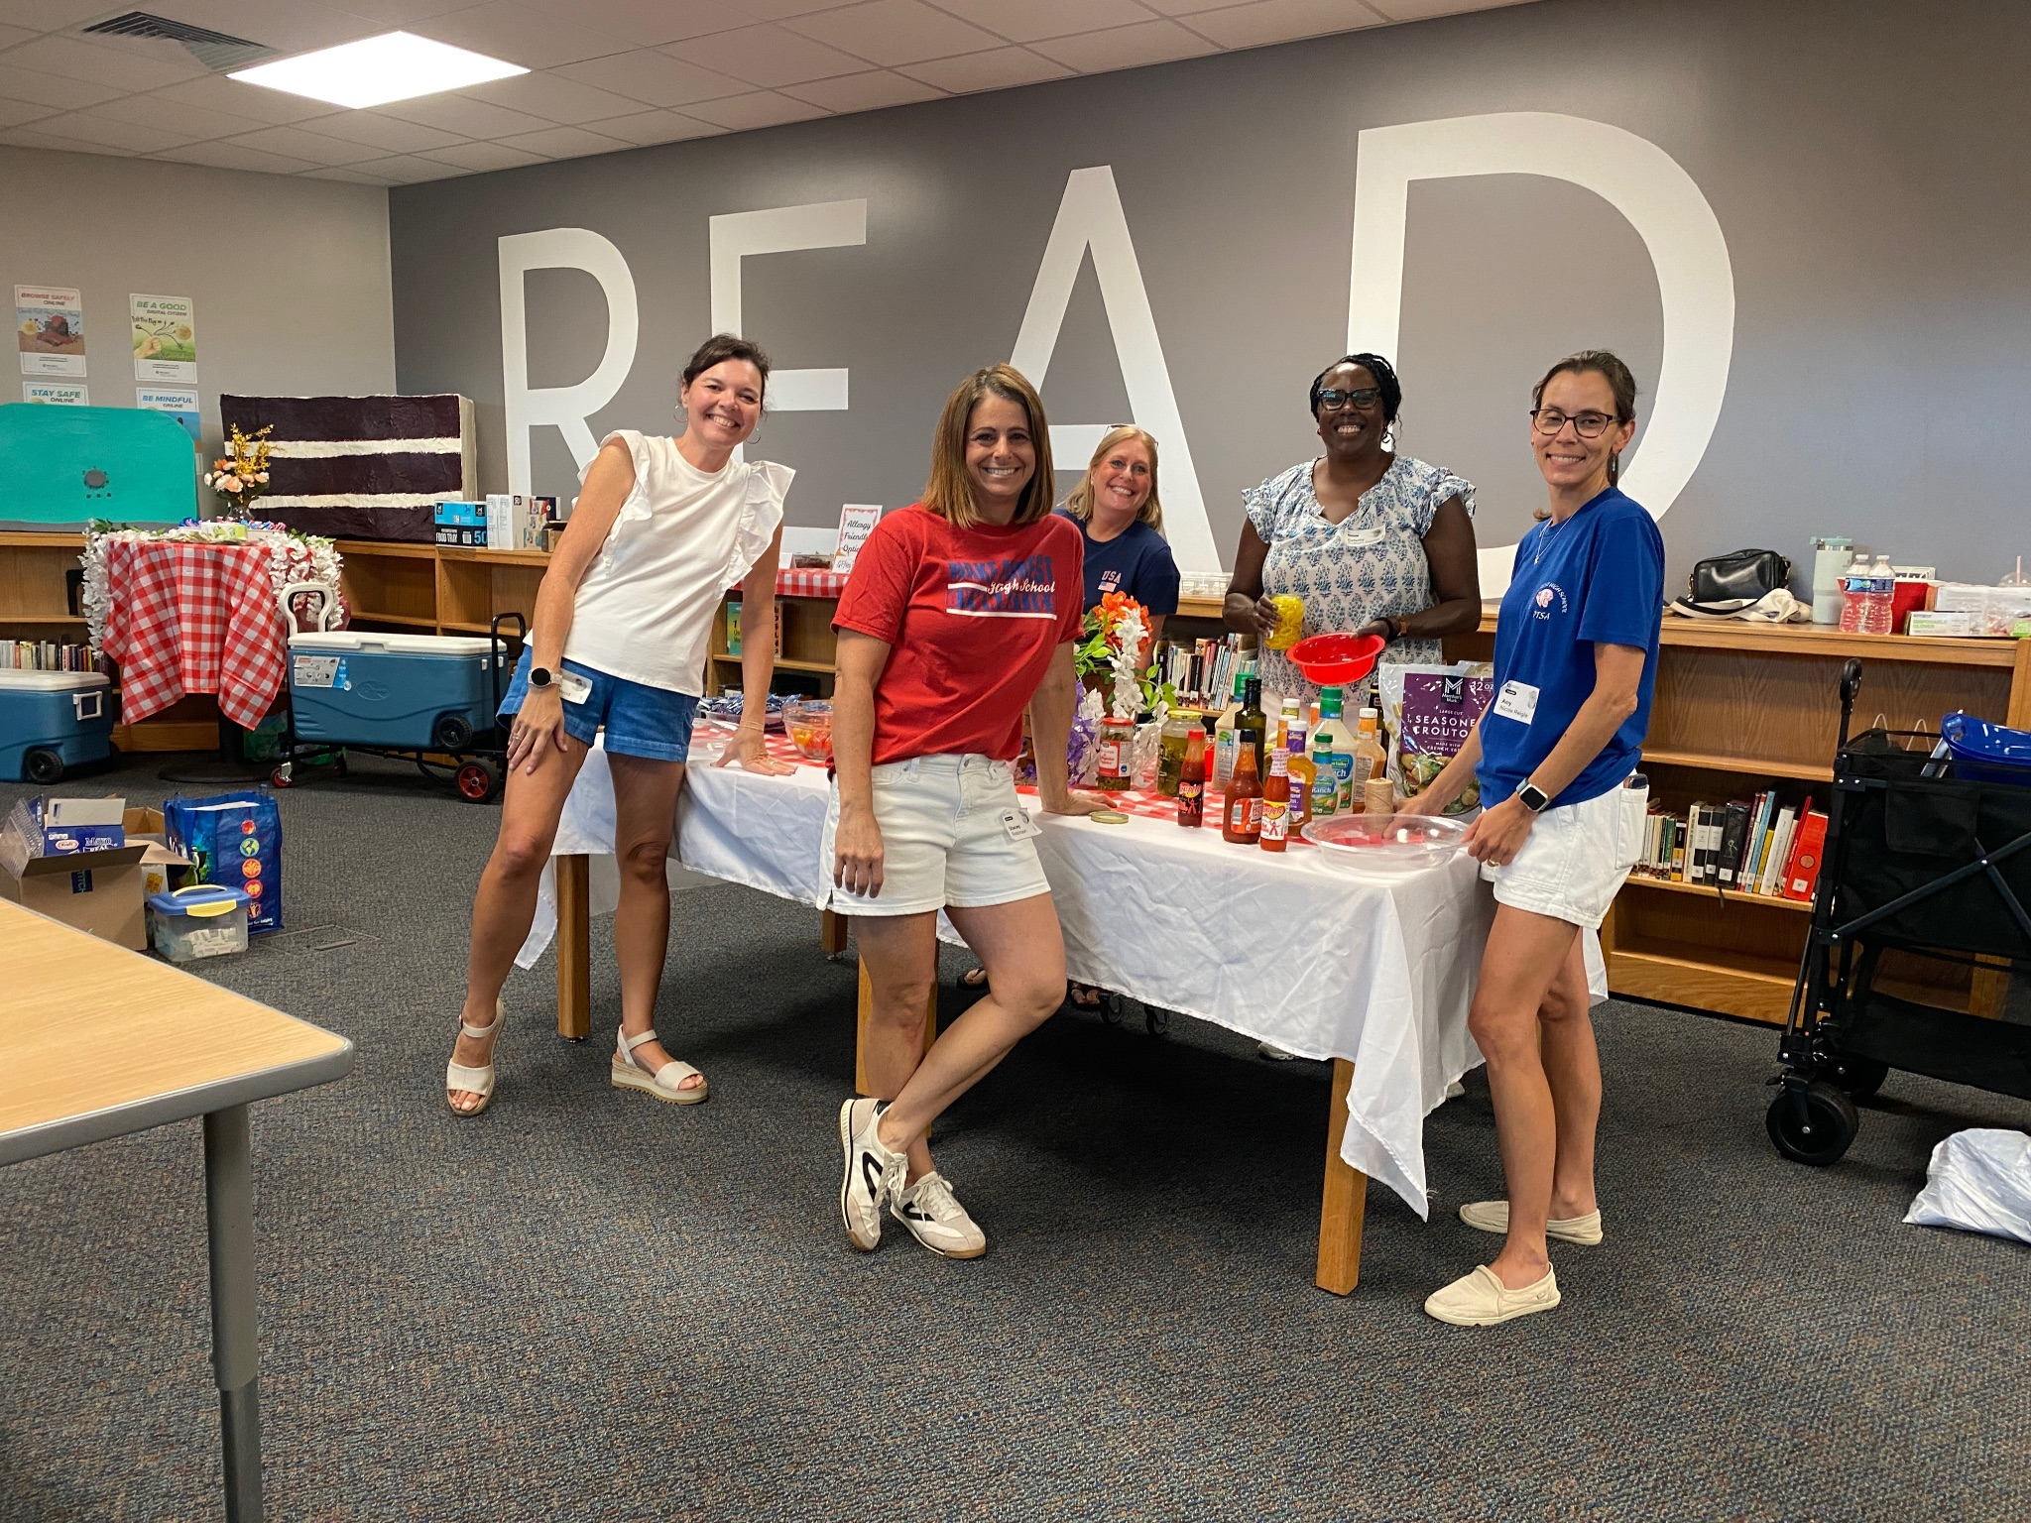

Graduating Class of 2027

“Deck the Deck” Recap
The seniors had a great time chalking their parking spots during Deck the Deck! Thanks to everyone who volunteered and donated popsicles and water for the event! We have some talented students!!
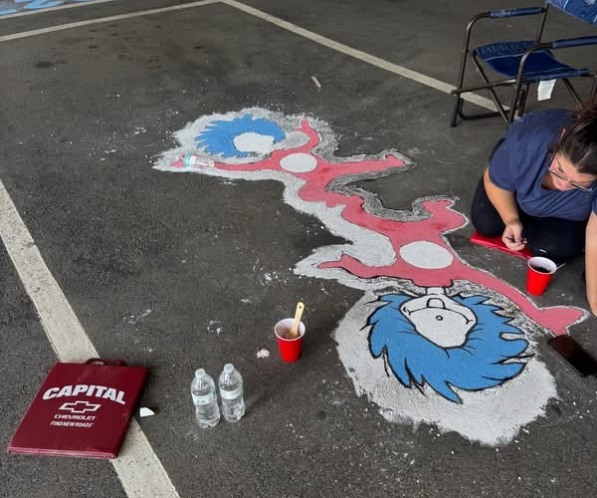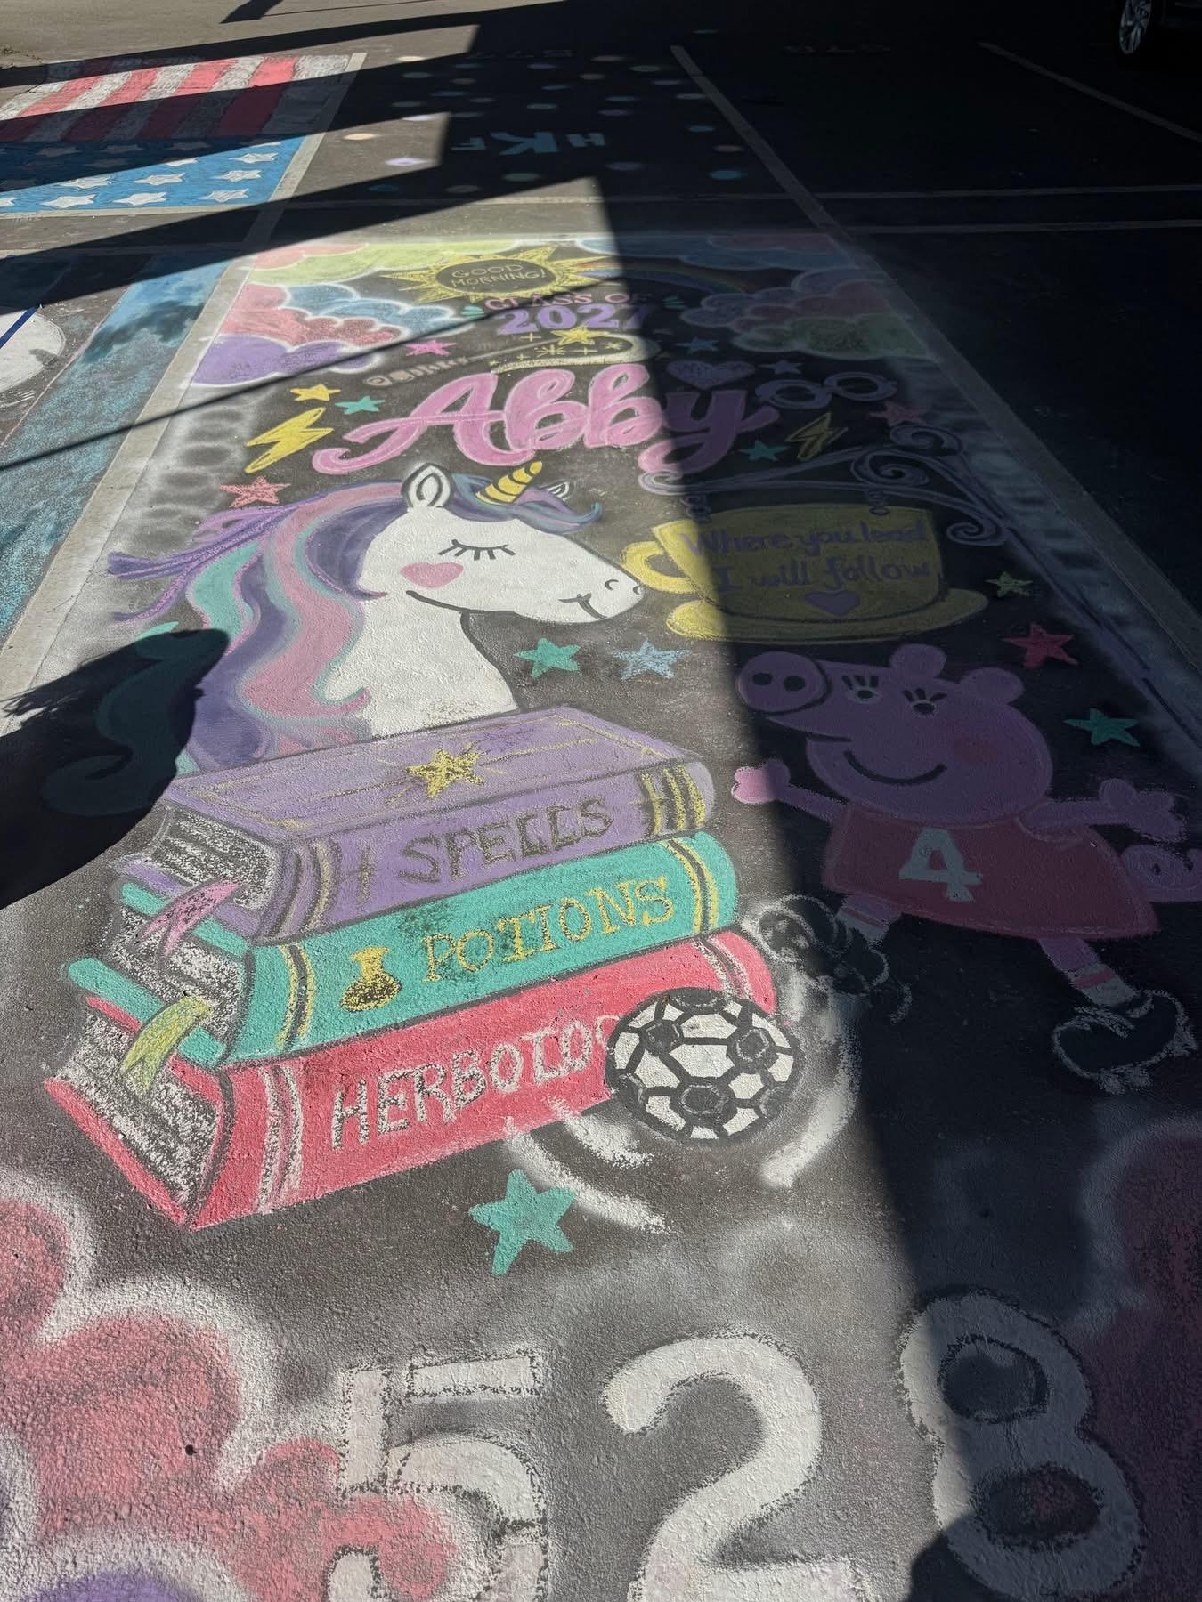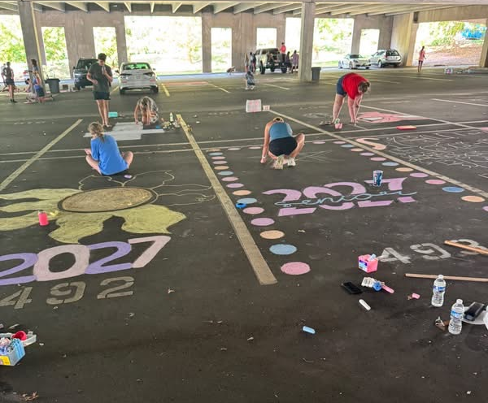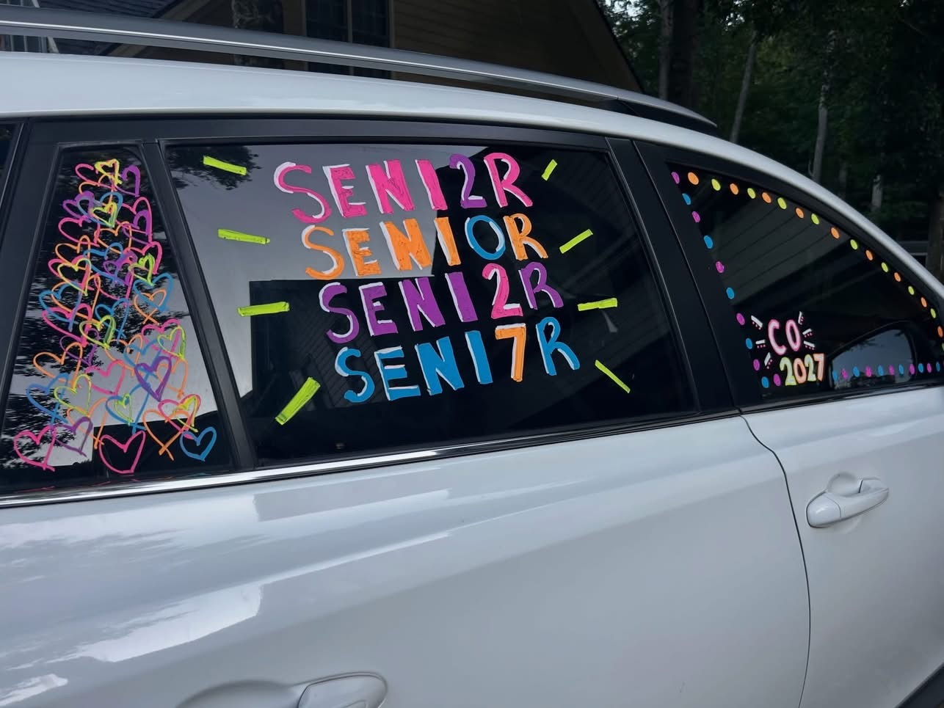
We’d also like to acknowledge and thank our WFHS Alum from Southern Shine Exterior Cleaning for powerwashing our senior parking deck in advance of the event. What an amazing show of school spirit! If you need powerwashing services, please consider supporting this wonderful local business.
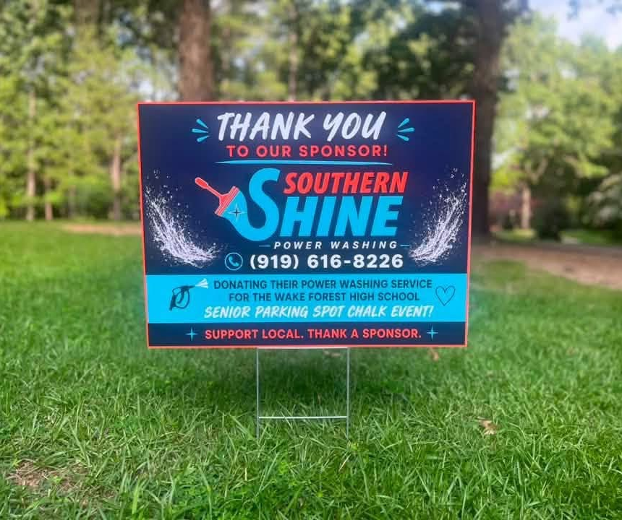

First Senior Treat Day
On Thurs, Sept 3rd, we will be distributing treats to the Class of 2027 during homeroom. Sign up here to volunteer.

Important Dates for Class of 2027:
Sept 3rd: 1st Senior Treats handed out during Homeroom
Sept 10th: Grad Night from 6-8 p.m. in the WFHS Auditorium
Feb 18th: Senior Breakfast
Jun 10th: Graduation is at 12 p.m. at the Raleigh Convention Center

Advocacy

One of our main focus points with Advocacy is Health and Wellness. We have been trying to spread awareness with our Student Health and Wellness Committee, as well as provide useful information that may help parents have meaningful conversations with their kids.
For the month of September, we are focusing on a positive start to our school year! We are calling it the Fall Reboot, and the themes revolve around a positive mindset. The four themes are body positivity, mind and soul, social habits, and balance. Look for posters around the school reminding us to stay positive! Here are some links with useful info and tools as we start the school year:
Body (for Teens) | Nemours KidsHealth
Mind (for Teens) | Nemours KidsHealth
Body Image and Self-Esteem (for Teens) | Nemours KidsHealth

Donate to The Giving Tree!

The Giving Tree is another one of our biggest fundraisers every year, and it is a super easy way to help our school earn money! Last year, we earned $4550 from them and had the most points again of any school in the area!! So thank you to everyone who donated and shopped at The Giving Tree last year! Here’s how it works:
The Giving Tree is a local non-profit that accepts donations from the community with the specific goal of using the proceeds to generate funds for local schools! Donating is simple. All you do is grab a paper bag or box, fill it with gently used home goods and/or toys, and drop it off any time at The Giving Tree (839 South Main Street).
They accept donations Monday-Saturday from 10:30 a.m. - 4:30 p.m. There is a list of allowed goods and donation instructions on the DONATE page of their website. Be sure to tell them your donation is for Wake Forest High School. So clean out those closets and take it over to The Giving Tree anytime during the week, as many times as you like! You get points for every donation AND points every time you shop, so don’t forget to look around while you are there. They are the cutest boutique!
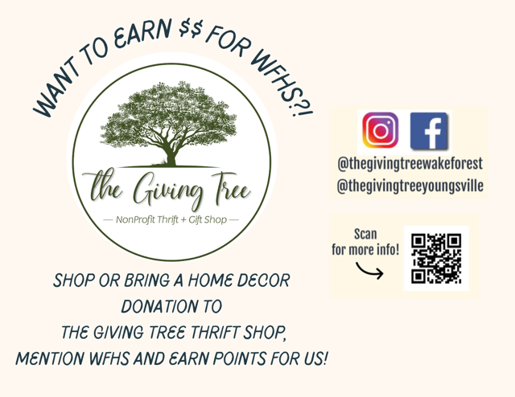

WFHS Student Clubs

Does your child have an interest in joining a Club? Want to learn about SGA? Do they want to know about the Honor Societies at the high school?
WFHS is hosting their Involve Fair on Wed, Sept 2nd after school and Thurs, Sept 3rd during both lunches. Students should request a pass from their 2nd period teacher!
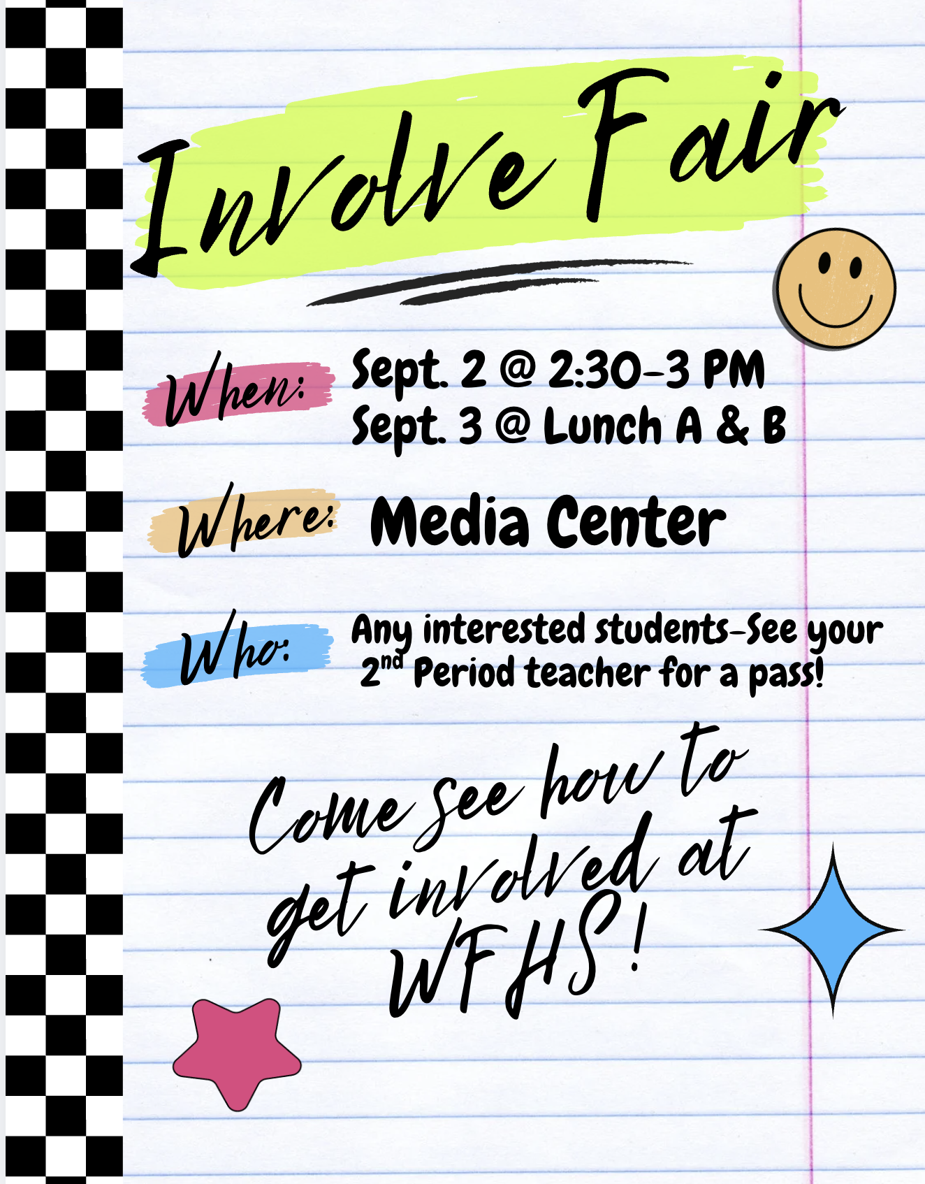

Traffic Patterns for Student Drivers and Carpool
Please click this link to watch a video of the traffic patterns for WFHS. Traffic can be heavy and these designated patterns will help reduce safety concerns. Please note that students should never be dropped off in the road for school. Students should only be dropped off in the designated carpool area.
Note: the video was produced three years ago but it’s still accurate today.
Please help us keep our school safe for students and staff by following this traffic pattern!
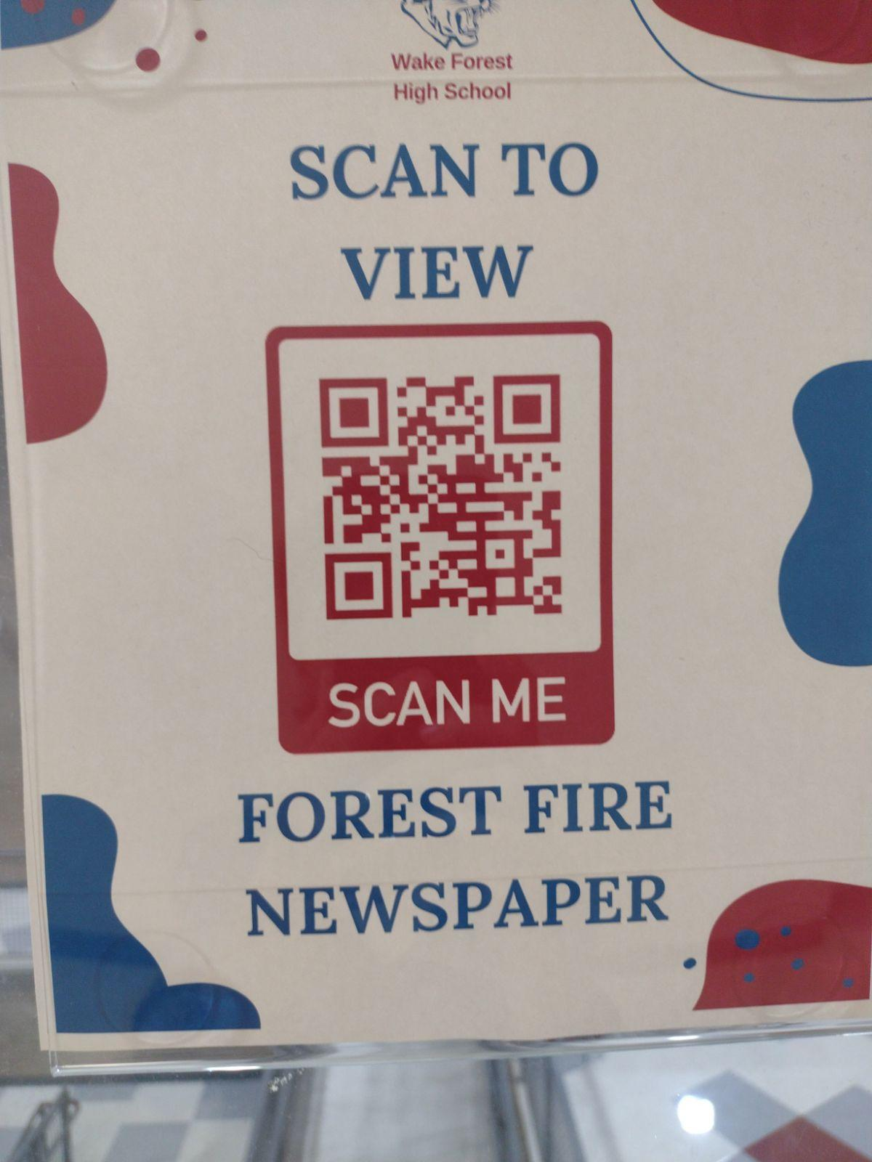

Student Newspaper
Scan the QR Code above or click this link to read the latest issue of WFHS Student News.

Helpful WFHS Links
Need to find a WFHS-related page, but can't find it ANYWHERE? Yeah, we get it! Here's your one-stop list of (almost) all things WFHS! If we're missing something, let us know so we can add it! Also, follow WFHS PTSA on Facebook, Instagram and X (formerly known as Twitter)!
Grade-Specific Facebook Pages
Freshman Class of 2030 Facebook Page
Sophomore Class of 2029 Facebook Page

Junior Class of 2028 Facebook Page

Senior Class of 2027 Facebook Page

READ MORE ON OUR WEBSITE


WFHS PTSA

