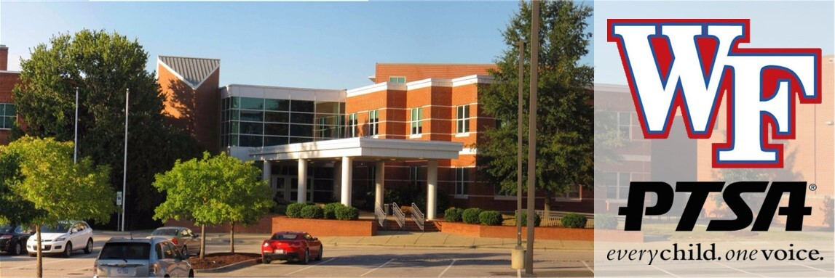

Wake Forest High School PTSA Newsletter

Welcome to our August Newsletter!

We are so excited to start gearing up for the new school year! There is still some summer left, but we want to help prepare you for the start of the 2026/27 school year. There are some fun events coming up so read on to find out more!
Our first board meeting of the year will be on Monday, August 10th at 6pm in the media center. Please email us at ptsa.wfhs@gmail.com if you need the google meet link to join virtually. Otherwise, we would love to see you there in person as we discuss our plans for this school year.
We will be having an informal Meet and Greet at Strike and Barrel on August 20th starting at 6pm. This is just a fun get together to chat and enjoy good friends! If you would like to come hang out with us, and maybe get to know us better, then come join us! If you have questions about anything at WFHS, we are a great resource and happy to help!
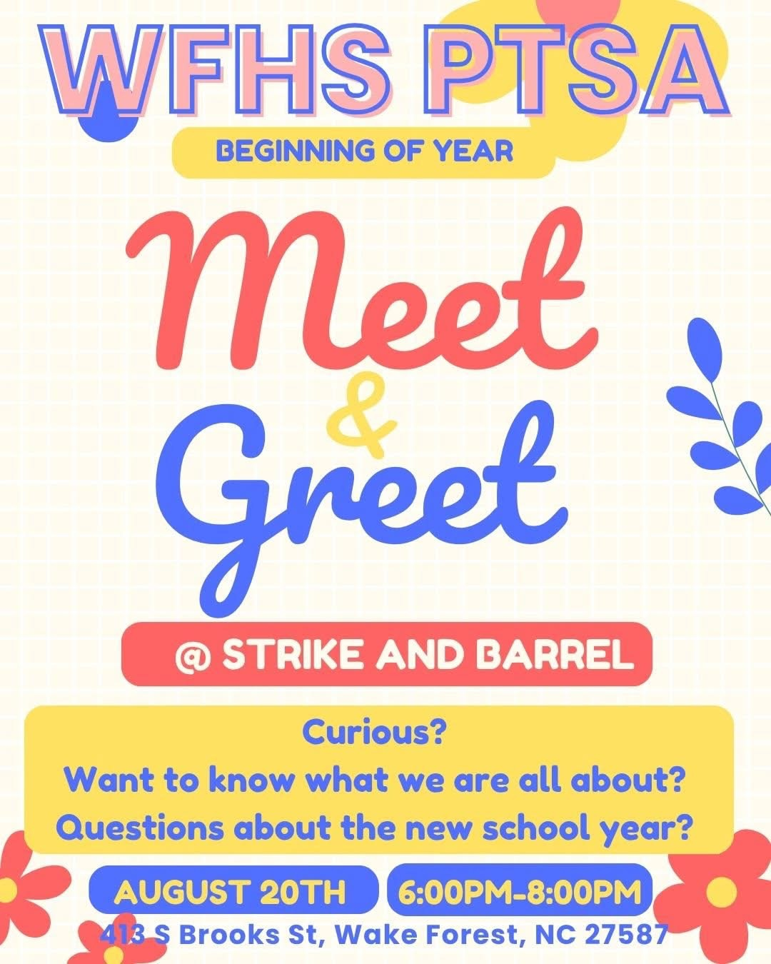

WFHS Cougar No-Fuss Fundraiser and PTSA Membership
Since we are starting a new year, it is now time to become a member of our PTSA for the 2026/27 school year.
Show your support by joining. You can be as involved as you want to be - by giving to our no-fuss fundraiser, donating food or supplies to staff and student events, helping us with planning or leading a committee. It’s totally up to you! We appreciate help of any kind.
Click this link to go to our website where you can become a member, donate to our no-fuss fundraiser, or both!
Our goal for this school year is to raise $5,000! Help us reach our goal!

While you are at it, you should have received an email about renewing your WCPSS volunteer status this year. Please make sure you do this asap so you can help when you want to!

Incoming Freshman Parents:

Cougar Camp for Incoming Freshmen will be August 6th!
If you haven’t already, please click the link so you can sign up to attend.
Session 1 will be from 8 am - 11 am and Session 2 will be from 1 pm - 4 pm.
This is an event for incoming freshman students to become familiar with the school before their first day. Drop your student off in the carpool lane!
Parents are welcome to come at either 10 am or 3 pm to attend their own parent session to get important information about what to expect this year. After the parent session, you can meet up with your child and walk your student’s schedule with them so they know where their classes are on the first day of school. Please make sure to come visit the PTSA at our table while you are there too!

🎓 New Student Walk-Through
WFHS will host their annual New Student Walk-Through on Thursday, August 13th from 10:30–11:30 AM. Any student (and family) new to WFHS is invited to attend during this time to walk through their schedule and get familiar with the building. No sign-up is required—just show up!
Please Note:
- Student schedules will not be printed and must be accessed through Infinite Campus.
- JROTC students will be available throughout the building to assist with directions; however, this is not a guided tour.

Hospitality

Our first hospitality event for this year will be on Tuesday, August 18th.
We are sponsoring a staff lunch to welcome back our teachers and staff for the start of the year. Click here to donate or volunteer to help. We really appreciate all you do to show our staff how special we think they are!
Want to find out how to help with fun events like this? Join the PTSA and email us at ptsa.wfhs@gmail.com to get in on the fun!
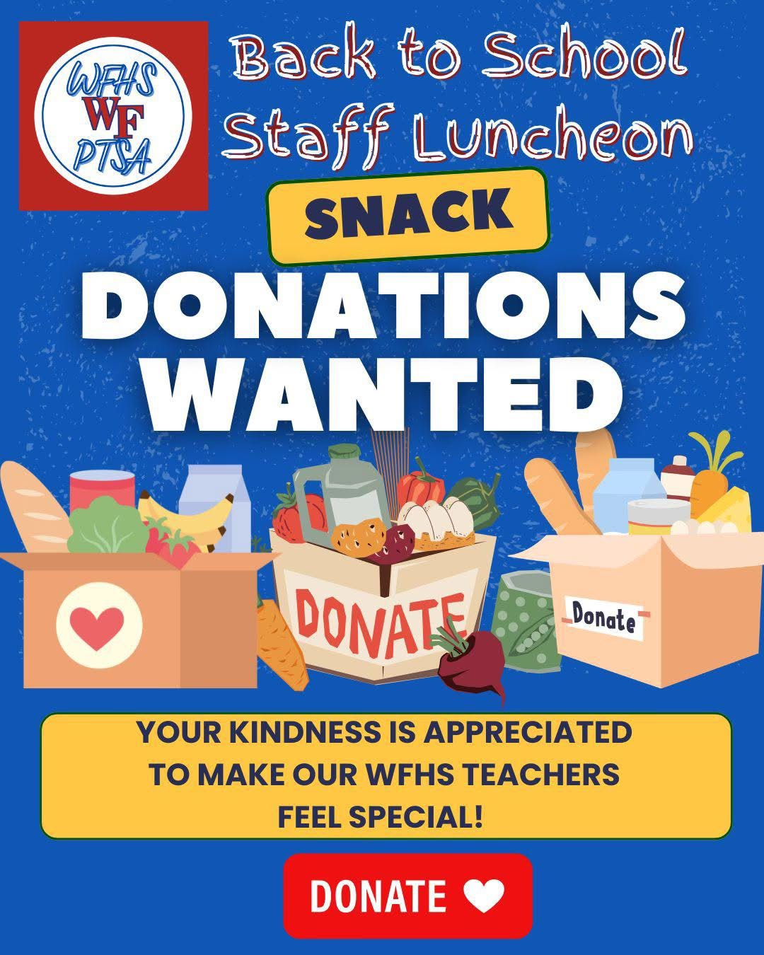

Graduating Class of 2027

Class of 2027, we are so excited to celebrate you this year! To start off the year, we will be doing Deck the Deck on Sunday, August 23rd from 3-5pm at the parking deck. Graduates, come out and either decorate your parking spot in the parking deck with chalk, or decorate your car with chalk paint to kick off the school year! We will provide chalk and water/popsicles, but you are welcome to bring your own if you wish. Click here to volunteer or donate to this fun event!



Come help us plan all the fun events for our graduating class of 2027 this year! All are welcome! You don’t have to have a senior to get involved. Our first planning meeting will be on Wednesday, August 19th at 6pm in the media center. Parents with underclassmen are also welcome to participate if you wish! We need lots of help!

On Thursday September 3rd we will be distributing treats to the class of 2027 in homeroom. Sign up here to volunteer.

Important Dates:
Aug 19th: first planning meeting for graduate events at 6pm in the media center
Aug 23rd: Deck the Deck
Sep 3rd: 1st senior treats handed out in homeroom

Donate to The Giving Tree!

The Giving Tree is one of our biggest fundraisers every year, and it is a super easy way to help our school earn money! We earned $4550 from them last year and had the most points again of any school!! So thank you to everyone who donated and shopped at the giving tree last year! Here’s how it works:
The Giving Tree is a local non-profit that accepts donations from the community with the specific goal of using the proceeds to generate funds for local schools! Donating is simple. All you do is grab a paper bag or box, fill it with gently used home goods or toys, and drop it off any time at The Giving Tree (839 South Main St.).
They accept donations Monday-Saturday from 10:30am - 4:30pm. There is a list of allowed goods and donation instructions on the DONATE page of their website. Be sure to tell them your donation is for Wake Forest High School. So clean out those closets and take it over to The Giving Tree anytime during the week, as many times as you like! You get points for every donation and points every time you shop, so don’t forget to look around while you are there. They are the cutest boutique!
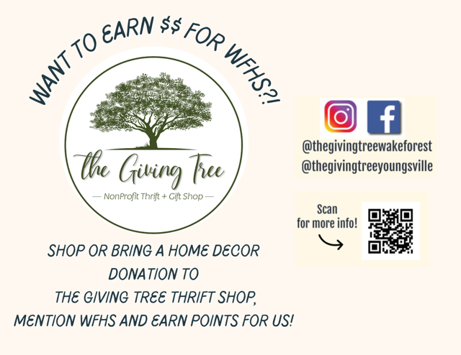

Parking Pass/Off-Campus Lunch pass Info

Please use this link which can be found on our school website for Parking Pass and Lunch Pass information. To receive a parking or off-campus lunch pass, students must complete the online application, submit all required notarized forms and documentation, and pay through School Cash Online. Once you complete all the application information and submit all forms, your pass can be picked up on campus on August 7, 11, 12, or 14. More information about the 2nd round will be shared after August 7th. Applications received after August 14 will be processed after August 28, and no passes will be issued on the first day of school. 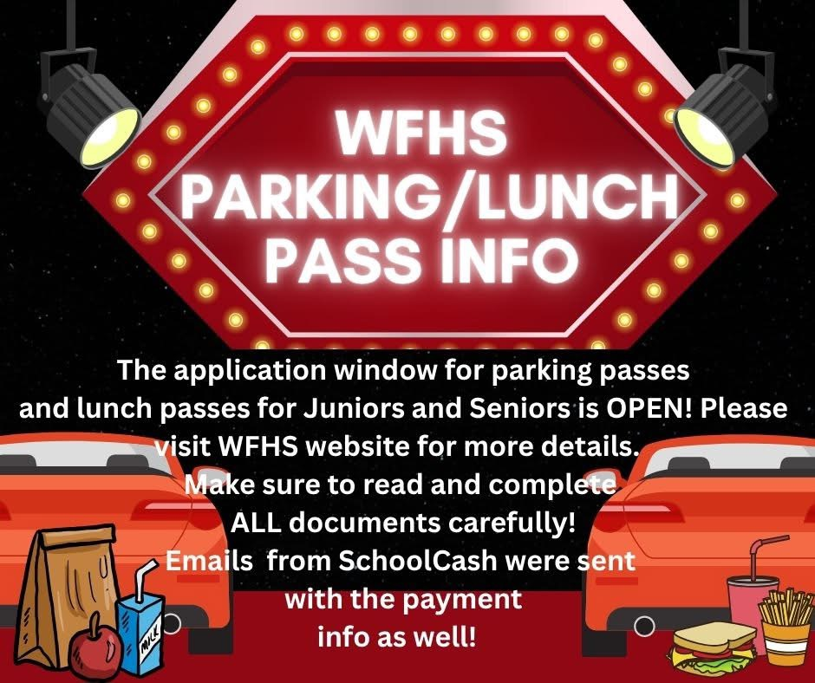

Traffic Patterns for Student Drivers and Carpool
Please click this link to watch a video of the traffic patterns for WFHS. Traffic can be heavy and these designated patterns will help reduce safety concerns. Please note that students should never be dropped off in the road for school. Students should only be dropped off in the designated carpool area.
Note: the video was produced three years ago but it’s still accurate today.
Please help us keep our school safe for students and staff by following this traffic pattern!


Student Newspaper
Scan the QR Code above or click this link to read the latest issue of WFHS Student News.

Helpful WFHS Links
Need to find a WFHS-related page, but can't find it ANYWHERE? Yeah, we get it! Here's your one-stop list of (almost) all things WFHS! If we're missing something, let us know so we can add it! Also, follow WFHS PTSA on Facebook, Instagram and X (formerly known as Twitter)!
Grade-Specific Facebook Pages
Freshman Class of 2030 Facebook Page
Sophomore Class of 2029 Facebook Page

Junior Class of 2028 Facebook Page

Senior Class of 2027 Facebook Page

READ MORE ON OUR WEBSITE


WFHS PTSA

