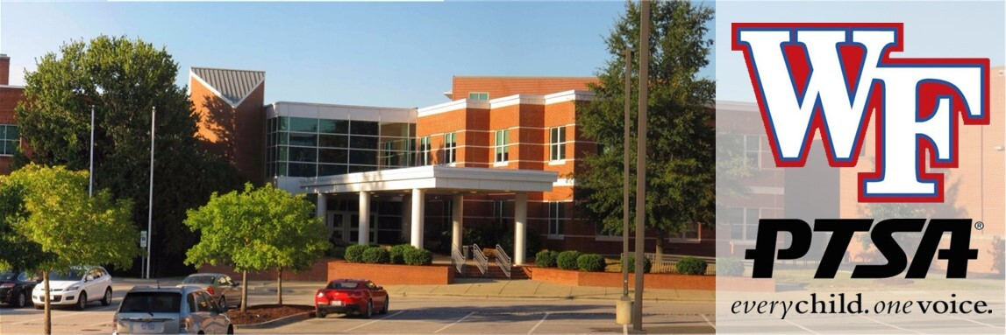

Wake Forest High School PTSA Newsletter

Welcome to our October Newsletter!

Upcoming PTSA events you don’t want to miss
Our next board meeting will be on Monday, October 12th at 6pm in the media center. Please email us at ptsa.wfhs@gmail.com if you need the google meet link to join virtually. Otherwise we would love to see you there in person as we discuss our plans for this year!
The first annual Principal Chat will be right before our meeting, starting at 5pm on October 12th. It’s a great way to get to know our principal and what’s going on at school, as well as ask any questions you may have. Then stay to see what’s happening with our PTSA!
Thank you to everyone who attended the General Assembly meeting after Meet the Teacher to help us pass our budget for the year. It was an amazing turnout, and we appreciate your support so much. It takes a village, and as a volunteer run organization, we can’t do this without all of you!

WFHS Cougar No-Fuss Fundraiser and PTSA Membership

 THANK YOU, COUGAR FAMILIES!
Thanks to the incredible generosity of our WFHS families and community, our PTSA No Fuss Fundraiser raised $5,425 - surpassing our $5,000 goal!
A HUGE thank-you to every family who supported our No Fuss Fundraiser! Your generosity helps the WFHS PTSA support programs, teacher and student grants, campus improvements, student events, teacher appreciation and more - all benefiting our entire Cougar community.
While our official No Fuss campaign has ended, donations are always welcome throughout the school year for anyone who missed the campaign or feels led to give. https://www.wfhs-ptsa.com/memberships-and-donations
 Thanks to the generosity of our amazing community sponsors, we have more than $1,500 in prizes to give away! Winners have been contacted by email and announced on our social media.
 Winners are invited to receive their prizes at our PTSA Meet & Greet!
Wednesday, October 7
 Strike & Barrel
We hope you'll join us - whether you win a prize or not! Come meet some of the awesome volunteers behind the WFHS PTSA, ask questions and simply hang out with other Cougar families.
And we promise, this isn't secretly a way to get you to volunteer. 
(But if you decide you want to, we happen to think you'll have a lot of fun!)
Thank you again for supporting WFHS!


Spirit Night
Our next spirit night is a special one, because it is sponsored by the Juniorette Women’s Club! They are such an amazing group who helps us every year by sponsoring this spirit night for us. Please consider eating out at Chipotle on Oct 21st from 4-8 pm to show your support!
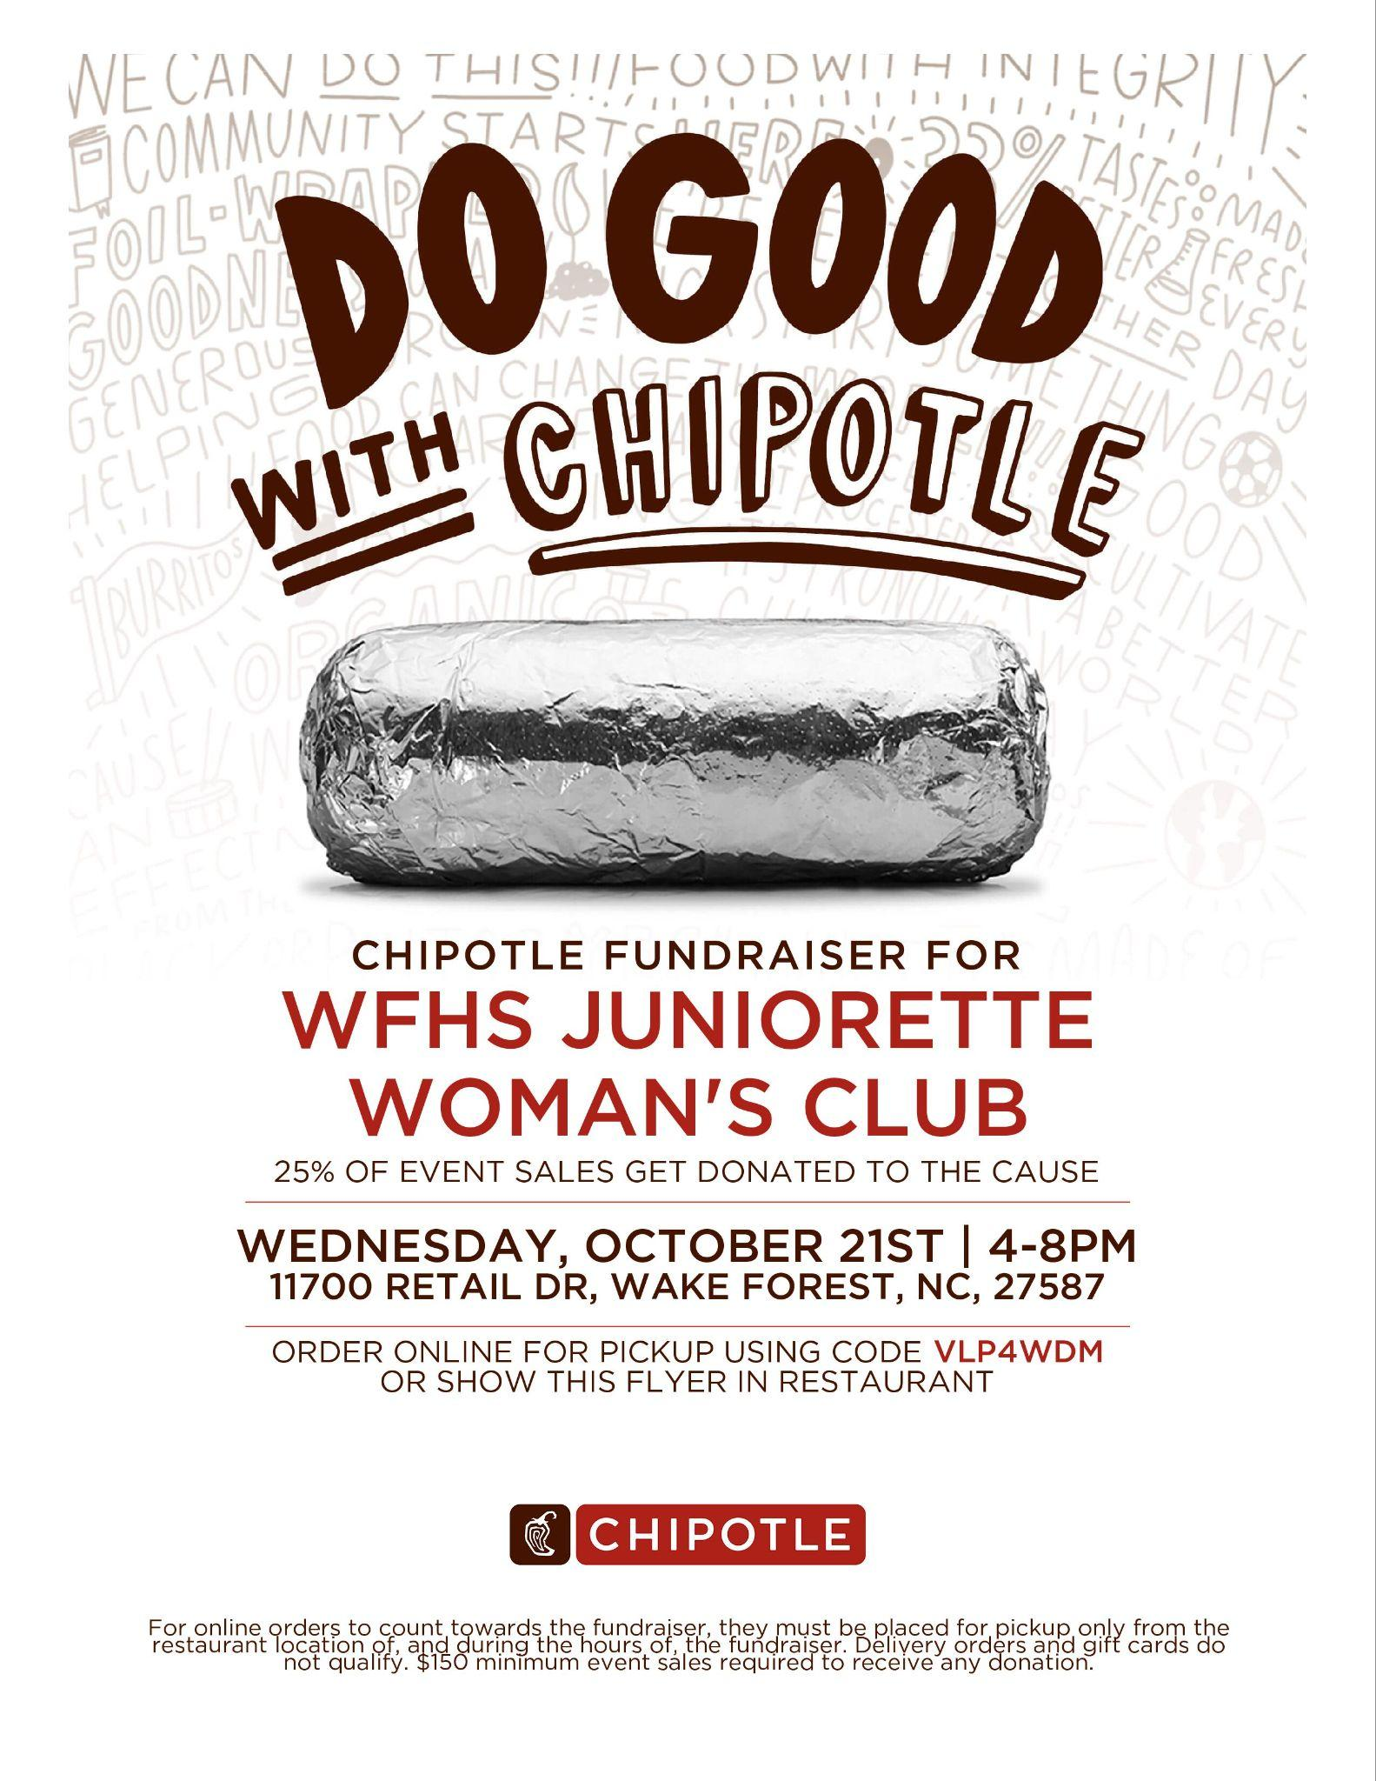

Ready to Volunteer?
You should have received an email about renewing your WCPSS volunteer status this year. Please make sure you do this asap so you can help out when you want to!

Hospitality

Bus Driver and Staff mailbox treats

In October, we will be showing appreciation to our bus drivers and delivering a treat to our staff's mailboxes. Keep an eye out for a SignUpGenius link near the end of October with details regarding the "Friendsgiving" lunch we are hosting for the staff on November 3rd.
We understand it is not always convenient to drop off donations at the high school during designated times. To make donating easier, we are introducing new options on SignUpGenius:
- Amazon Wishlist: Order items directly from Amazon and have them delivered to the school (420 W Stadium Ave) by following the instructions in the sign-up.
- Digital Gift Cards: Email gift cards directly to the PTSA.
Thank you again to everyone who supports us throughout the year to show appreciation for our staff and students. If you would like to help with future events, please consider joining the PTSA or emailing us at ptsa.wfhs@gmail.com.
Want to find out how to help with fun events like this? Email us at ptsa.wfhs@gmail.com to get in on the fun!

Appreciation Post

Thank you to everyone who donated and volunteered in Sept for the Fall Cougar Dash 2026! We truly could not host these events without the support of our WFHS PTSA family. Thanks to your generosity, we were able to provide a wide range of treats, including fun drink mixes for the staff, which were a joy to deliver.

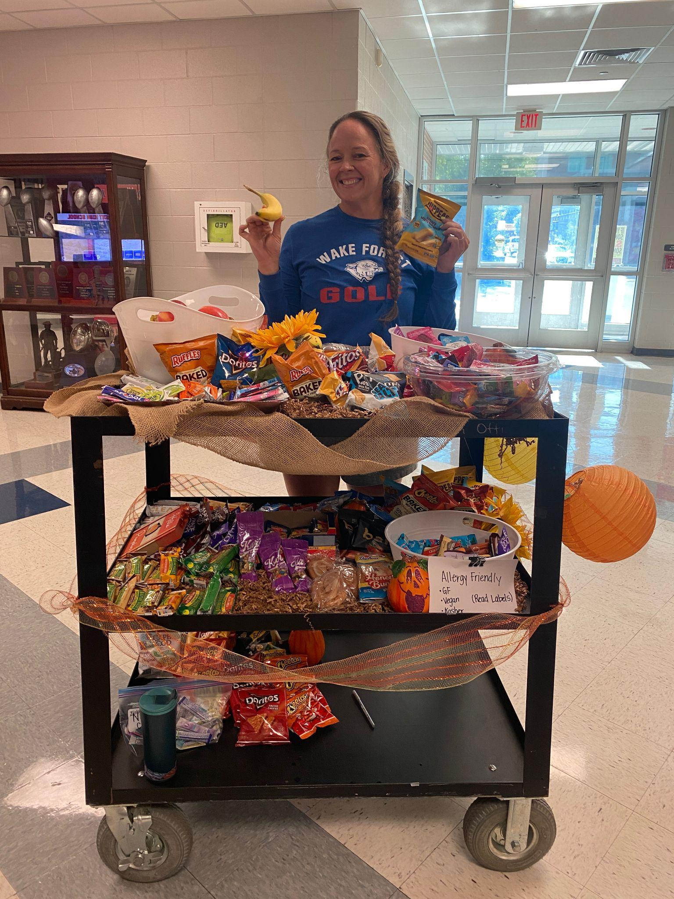

Graduating Class of 2027

First Senior Treat Day
On Thurs, Sept 3rd, we distributed Krispy Kreme donuts to the Class of 2027 during homeroom. Yum!
Our next senior planning meeting will be on Wednesday, October 28th at 6pm in the media center. This will be a working meeting where we will pack snacks for treat bags we deliver with report cards in November, as well as doing some planning. We have lots more to do to plan for a fun senior year so come join us! Here is the sign up to donate for the Senior treat bags - CLICK HERE
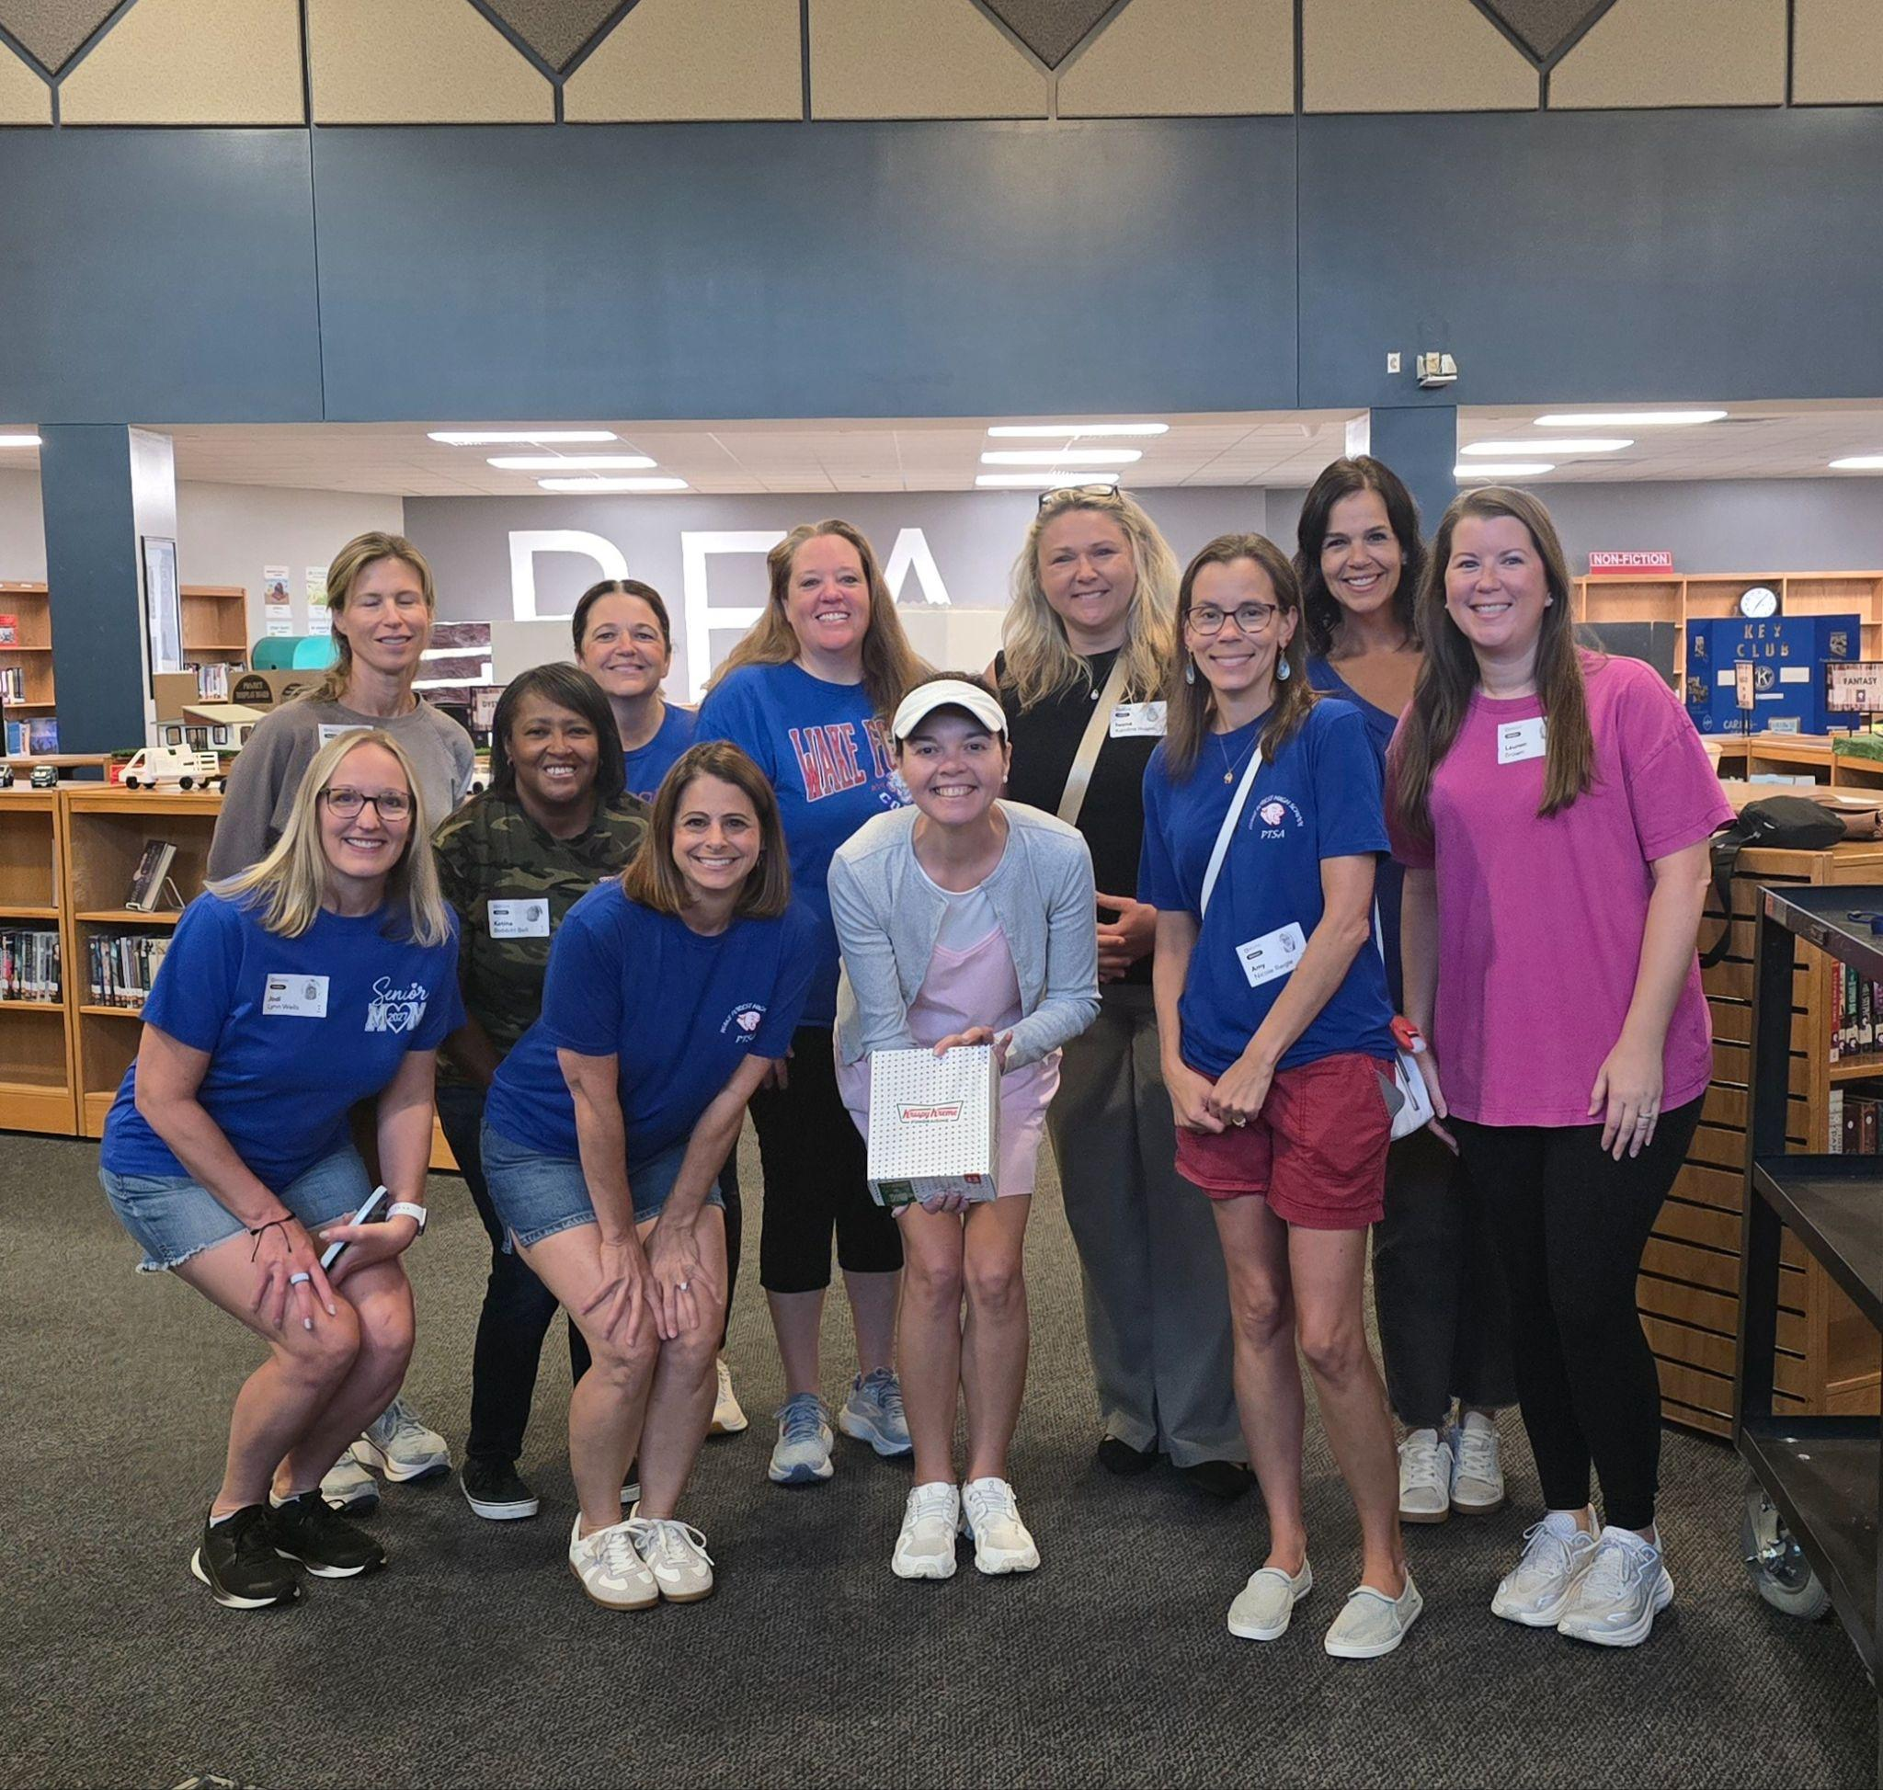
You may now pay senior dues. Log into your school cash online account and pay your senior dues. These dues are $62.50. Dues go to pay for diplomas, diploma covers, flowers and more for graduation and other senior events. Students must log into their Wake ID and School Cash Online. The senior dues will be attached to be able to pay. Please make sure you have your dues paid by May 1st. Students who fail to pay senior dues will not be given graduation tickets.

Important Dates for Class of 2027:
Oct 28th: packing quarterly treat bags and planning meeting at 6pm
Feb 18th: Senior Breakfast
May 1st: Senior Dues must be paid
Jun 10th: Graduation is at 12 p.m. at the Raleigh Convention Center

Advocacy

Supporting Our Teens, Supporting Ourselves:
September is Suicide Prevention Awareness Month, an important time to talk about the mental health of our teens and the well being of the adults who care for them.
According to the CDC’s 2023 Youth Risk Behavior Survey, 4 in 10 high school students reported persistent feelings of sadness or hopelessness, while 1 in 5 seriously considered attempting suicide. These numbers remind us how important it is to stay connected with our young people and create an environment where they feel comfortable asking for help.
For our teens:
• Check in often and listen without judgment.
• Pay attention to meaningful changes in mood or behavior.
• Encourage healthy friendships, activities, and support systems.
• Remind them that asking for help is a strength.
• Let them know they can always come to you, even when the conversation is difficult.
And parents, don't forget about yourselves.
Supporting a teenager can be emotionally exhausting. Give yourself permission to take a break, ask for help, get enough rest, and make time for the things that help you recharge. You don't have to be a perfect parent, and you don't have to carry every concern alone.
A healthy support system starts with connection, for our children and for ourselves. When parents take care of their own mental health, they are better able to be present and supportive for their children.
If you or someone you know is experiencing a mental health crisis or thoughts of suicide, call or text 988 for the Suicide & Crisis Lifeline.
As September comes to a close, let’s carry these conversations with us throughout the school year. Keep checking in, keep listening, and remember that taking care of yourself is part of taking care of your family.

Student Health and Wellness Committee

One of our main focus points with Advocacy is Health and Wellness. We have been trying to spread awareness with our Student Health and Wellness Committee, as well as provide useful information that may help parents have meaningful conversations with their kids.
For the month of September, we are focusing on a positive start to our school year! We are calling it the Fall Reboot, and the themes revolve around a positive mindset. The four themes are body positivity, mind and soul, social habits, and balance. Look for posters around the school reminding us to stay positive! Here are some links with useful info and tools as we start the school year:
Body (for Teens) | Nemours KidsHealth
Mind (for Teens) | Nemours KidsHealth
Body Image and Self-Esteem (for Teens) | Nemours KidsHealth

Donate to The Giving Tree!
Oct 5-10th is Double Points for donations!
Donate this week and we earn Double Points for every donation to the Giving Tree!
The Giving Tree is one of our biggest fundraisers every year, and it is a super easy way to help our school earn money! Last year, we earned $4550 from them and had the most points again of any school in the area!! So thank you to everyone who donated and shopped at The Giving Tree last year! Here’s how it works:
The Giving Tree is a local non-profit that accepts donations from the community with the specific goal of using the proceeds to generate funds for local schools! Donating is simple. All you do is grab a paper bag or box, fill it with gently used home goods and/or toys, and drop it off any time at The Giving Tree (839 South Main Street).
They accept donations Monday-Saturday from 10:30 a.m. - 4:30 p.m. There is a list of allowed goods and donation instructions on the DONATE page of their website. Be sure to tell them your donation is for Wake Forest High School. So clean out those closets and take it over to The Giving Tree anytime during the week, as many times as you like! You get points for every donation AND points every time you shop, so don’t forget to look around while you are there. They are the cutest boutique!
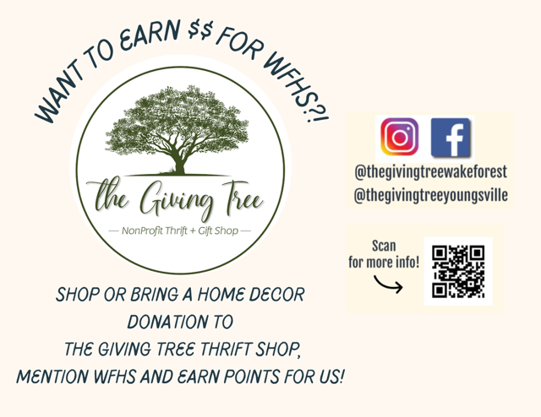

Attendance

Keep Your Student on the Attendance Track @ WFHS!
Did You Know?
- Students should miss no more than 9 days of school each year to stay engaged, successful, and on track to graduate.
- By 9th grade, attendance is an even stronger predictor of graduation than 8th-grade test scores!
How You Can Help
- Talk about attendance: Emphasize the importance of showing up to school every day.
- Support healthy routines: Help your student stick to consistent habits—completing homework, getting enough sleep, and arriving on time.
- Stay connected: Know your student’s friends and encourage positive peer influences.
- Get involved: Encourage participation in after-school clubs, sports, or activities to build a stronger connection to school.

Traffic Patterns for Student Drivers and Carpool
Please click this link to watch a video of the traffic patterns for WFHS. Traffic can be heavy and these designated patterns will help reduce safety concerns. Please note that students should never be dropped off in the road for school. Students should only be dropped off in the designated carpool area.
Note: the video was produced three years ago but it’s still accurate today.
Please help us keep our school safe for students and staff by following this traffic pattern!
Student Newspaper
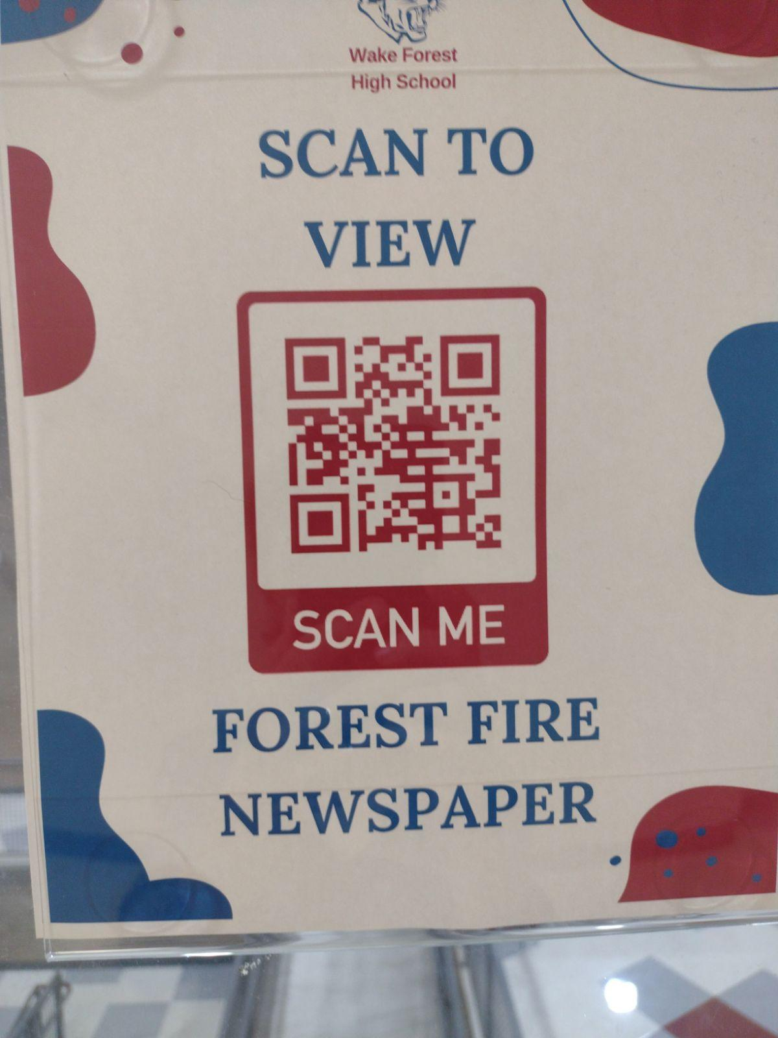
Scan the QR Code above or click this link to read the latest issue of WFHS Student News.

Helpful WFHS Links
Need to find a WFHS-related page, but can't find it ANYWHERE? Yeah, we get it! Here's your one-stop list of (almost) all things WFHS! If we're missing something, let us know so we can add it! Also, follow WFHS PTSA on Facebook, Instagram and X (formerly known as Twitter)!
Grade-Specific Facebook Pages
Freshman Class of 2030 Facebook Page
Sophomore Class of 2029 Facebook Page

Junior Class of 2028 Facebook Page

Senior Class of 2027 Facebook Page

READ MORE ON OUR WEBSITE


WFHS PTSA

